TJX US Store Systems

Vendor Guide
  - V1.1.0
Release

Contents
Revision Control 4
1. Introduction 5
2. Data Room 6
Cabling Requirements 6
Data Rack Layout 7
3. Fortinet network switch – TJX vlan configuration 8
Store Switches 8
Loss Prevention (LP) Switches 9
4. Front -Line Cutover 10
De-Installation of Front-Line Registers: 10
Re-Installation of Registers- SPACE POLES. 14
Re-Installation of Registers- STANDARD 21
5. Call Forward Systems 25
QBUSTER 2 Installation 25
QBUSTER 2 Call Forwarding MDU Installation 29
QBUSTER 1 Call Forwarding Installation 30
6. Frontline Phones: 33
7. Jewelry Counter 35
8. TRIPP LITE Power Conditioner & Line Conditioner 36
9. UPS Battery Upgrade- replacement of existing batteries in UPS 38
10. Back Office System Installation 39
11. Staff Lounge 39
Time Clock Tear Down & Set Up 39
Staff Lounge TV 43
12. Project Closeout 44
13. Appendix: 45
Procedure for UPS manual Bypass 45
Liebert GTX3 and GTX4: 45
Liebert GTX5: 45
Oneac Synergy SEII: 46
UPS Battery Upgrade- replacement of existing batteries 47
Oneac SEII UPS 47
LIEBERT UPS Battery Upgrade- replacement of existing batteries in Liebert UPS 51
GXT3 51
GXT4 53
GXT5 56

Revision Control
Date | Author | Version | Revision Notes
12.6.24 | Apurva Ghawate | 0.1 | Initial Draft.
12.30.24 | Apurva Ghawate | 0.2 | Organized sections in order and added inputs from the team.
1.14.25 | Apurva Ghawate | 0.3 | Added Appendix section for UPS battery upgrades.
2.25.25 | Hark Hsueh | 1.0 | Remove cabling scope.
Date | Author | Version | Revision Notes

Introduction
Scope and Purpose

This Guide outlines the configuration and process of converting TJX stores for use with new equipment and counters. Includes the removal of the old front counter and installation of the new counter with all related processes involved.

General Conduct

In the remodel of any TJX stores the contractor will be required to work in conjunction with other vendors. For example, on cutover night you will be sharing space with the electricians. You will have to work together to complete the task at hand. The ability to schedule and compromise with other vendors is crucial. You will have to remain in contact with the manager of the store and keep them informed as to what is happening in the renovation, any delays or anything you require from them must be clearly conveyed to them.

Professionalism while you work is important as you are representing TJX while you complete this process.

Acronyms (non-technical)
AM Assistant Manager
CO Cash Office
DM District Manager
DC District Coordinator
DLPM District Loss Prevention Manager
LP Loss Prevention

List of Materials Not Provided by TJX (but required for installation)

In this version of the document, the following items are only for the installation of PDU poles; no other systems require special tools that require identification in this document.
- 4 – 12x1 screws for CDU pole
- 1 – 12x1 ½” bolt, washer and nut for CDU pole (to fully anchor to millwork)
- 2 1/8” drill bit
- Phillips head screwdriver
- A Laptop
- Standard Install: Drill, Drill bits, Basic FE Tool kit
- Space Pole Install: same as Standard Install plus:
    - Self-drilling screws (Pan Head Phillips 1/4” x 1 1/2” box of 100)
    - 1 1/2” hole saw & 2 1/4” hole saw

Data Room

Cabling Requirements
A TJX store requires the following standards when pre-cabling both voice and data cable:

- All cable runs must be less than or equal to 350 feet (if a store cable run exceeds this distance, please notify TJX Systems Implementation Team)
- All data, voice, and security cables (CAT6) are to be white
- FT6 cable is the standard cable used
- CAT6 cables must be as far away from potential sources of EMI (electrical cables, transformers, light fixtures, etc.) as possible. Do not tie cables to electrical conduits, or lay cables on electrical fixtures
- All cables must be supported by the roof support system, unless code specifies otherwise. Do not tie to the T-bar grid support under any circumstances
- Use J-hooks to support the cables (if required)
- Install proper cable supports, spaced no more than 5 feet apart
- Utilize Velcro and tie wraps to organize bundles of cables in ceilings
- All cables over the sales floor with open ceilings are to use conduits provided by the GC
- All cables over offices are to use a 2” conduit provided by the GC
- Any cables in the warehouse and data room are to run through free air. If conduits are provided, ensure they are delivered to the right location before completing cabling
- Any ceiling tile removed for cable runs must be restored back into its original state. If they are damaged make sure to replace them.
- All exposed cables must be hidden and clean up behind drywall/above ceiling tiles, away from the public view.

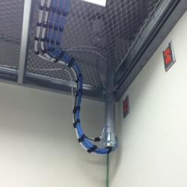

Cables neatly velcro'd and bundled into the conduit in data room

Data Rack Layout
Under construction…

Fortinet network switch – TJX vlan configuration

Store Switches
Note- every cable must be labelled. Label must follow TJX standards

Standard Configuration - Switch H - H4
PORT # | DEVICE | PORT # | DEVICE
1 | VH1\POS | 25 | Store - WebPC
2 | Controller T/C | 26 | Back Office
3 | POS | 27 | Back Office
4 | POS | 28 | Back Office
5 | POS | 29 | Back Office
6 | POS | 30 | Back Office
7 | POS | 31 | Back Office
8 | POS | 32 | Back Office
9 | POS | 33 | Back Office
10 | POS | 34 | Back Office
11 | POS | 35 | Back Office
12 | POS | 36 | District Office
13 | POS | 37 | District Office
14 | POS | 38 | District Office
15 | POS | 39 | District Office
16 | POS | 40 | SCCM\LPVM-VH2
17 | POS | 41 | Music\CORP
18 | POS | 42 | IP Office (Avaya)
19 | POS | 43 | VH1-HOST-CORP
20 | Wireless | 44 | VH2-HOST-CORP
21 | Wireless | 45 | ILO-VH1-CORP
22 | Wireless | 46 | ILO-VH2-CORP
23 | Wireless | 47 | FORTIGATE 201E Extender
24 | Wireless | 48 | 60F FIREWALL PORT A
 |  | 49 | X-Over SFP REQUIRED COPPER or FIBER
 |  | 50 | X-Over SFP REQUIRED COPPER or FIBER
 |  | 51 | X-Over SFP REQUIRED COPPER or FIBER
 |  | 52 | HP VH2 Server PORT 3 VLAN LINK (SFP)
POS = GREEN Patch Cords - Registers / Debit / Controller
Back Office = Thin Clients = Yellow / WebPC, AMM, Printers, EMS, INT, CO Scale (Marshalls) = Blue
Wireless = GREY Patch Cords - BCM and Access Points
CORP = PURPLE Patch Cords - WIPS, Music, VSAT,Firewall, IP Office (Avaya), SCCM

Loss Prevention (LP) Switches

Note:
- Every cable must be labelled. Label must follow TJX standards
- If camera exceeds number 39 another patch panel and switch is needed.

Standard Configuration - LP CCTV
PORT # | DEVICE | PORT # | DEVICE
1 | LP CAMERA | 25 | LP CAMERA
2 | LP CAMERA | 26 | LP CAMERA
3 | LP CAMERA | 27 | LP CAMERA
4 | LP CAMERA | 28 | LP CAMERA
5 | LP CAMERA | 29 | LP CAMERA
6 | LP CAMERA | 30 | LP CAMERA
7 | LP CAMERA | 31 | LP CAMERA
8 | LP CAMERA | 32 | LP CAMERA
9 | LP CAMERA | 33 | LP CAMERA
10 | LP CAMERA | 34 | LP CAMERA
11 | LP CAMERA | 35 | LP CAMERA
12 | LP CAMERA | 36 | LP CAMERA
13 | LP CAMERA | 37 | LP CAMERA
14 | LP CAMERA | 38 | LP CAMERA
15 | LP CAMERA | 39 | LP CAMERA
16 | LP CAMERA | 40 | POS\LPTC\THC3
17 | LP CAMERA | 41 | WIRELESS VLAN
18 | LP CAMERA | 42 | LP WORKSTATION\SERVER CORP
19 | LP CAMERA | 43 | LP WORKSTATION\SERVER CORP
20 | LP CAMERA | 44 | CORP VLAN
21 | LP CAMERA | 45 | Back Office VLAN
22 | LP CAMERA | 46 | Back Office VLAN
23 | LP CAMERA | 47 | Back Office VLAN
24 | LP CAMERA | 48 | Back Office VLAN
 |  | 49 | X-Over SFP REQUIRED COPPER or FIBER
 |  | 50 | X-Over SFP REQUIRED COPPER or FIBER
 |  | 51 | X-Over SFP REQUIRED COPPER or FIBER
 |  | 52 | HP VH2 Server PORT 3 VLAN LINK (SFP)
CCTV = Black Patch Cords

Front -Line Cutover
This section includes De-Installation of Front-Line Registers and Re- Installation of Front-Line Registers.

De-Installation of Front-Line Registers:
- Cables
- Registers (POS, Qbuster, pinpads)

Beginning Process (label all components before disconnecting)
Taking out the old counter and putting a new one at the same night. It’s important to note that this process should be carried out by a qualified professional to ensure safety and compliance with local building codes.
Remaining merchandise and loose peripherals be taken off the counter then we will verify that all registers have been closed by the store associates and can be turned off. Some counters will have extra fixtures that need to be removed.

Document the Setup
Take pictures or diagram the current setup, including the location of all cables and outlets. This will be helpful when reconnecting everything at the new counter.

IMPORTANT: SEQUENCING OF REGISTERS MAY NEED TO BE REVERSED DURING RE-INSTALLATION.
For Marshalls and TJMaxx stores you may need to reverse the register sequence if not already done starting with Register #1 being installed at the counter closest to where the customer is waiting at the exit of the Queue line, then register #2, then register #3, etc. Another way to understand this: there is (1) queue for customers to enter to pay for their merchandise and the register in front of them should be Register #1.
For HomeGoods stores Register #1 needs to be at the counter furthest to where the customer is waiting at the exit of the Queue line; the highest numbered register will be the first register that customers come to in the queue.

Demolition, Electricians, and Network Cables
The electricians will turn off the power to the front counter and work on disconnecting power from the counter. They must reconnect the power to the new counter.
You must disconnect the network cables from the counter keeping in mind that you are going to reconnect the network cables at the new location.
Note: The wiring process will change depending on how the cables are routed to the front counter at each site. Conduits can change where the wires must come down from.

Procedure to De-install Front Line registers
Coordinate with the Store MOD running the End-Of-Day process (XSTORE) on all registers. The XSTORE End of Day Process is complete when all registers have rebooted.

Note: End of Day process for XSTORE must be completed before any registers can be de-installed (EOD Process takes approx. 1 – 1 ½ hours to complete)

Registers will scroll files as shown.
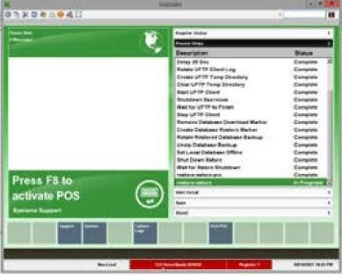

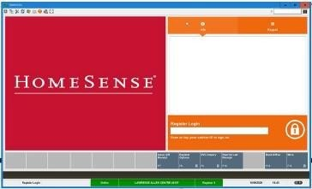
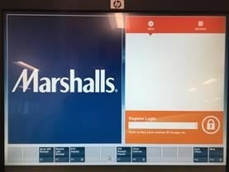
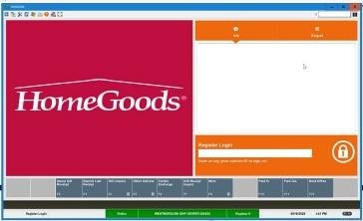
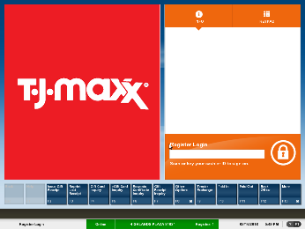
Store Close procedure is complete when the register display is as shown.
You may now Power-down each register being de-installed.
Register Power-down procedure:
At the Register Display press Ctrl, Alt, & Del
In the lower right-hand corner press the up arrow & select Shut Down
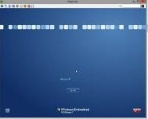
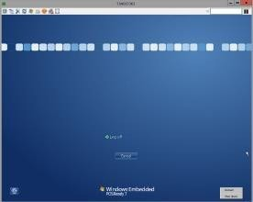

Shut Down

Note: Keep the pin-pad and register together, the Pin Pad must be relocated with the Register it is connected to.

De-install the register, all peripherals, and the call-forwarding display.
De-install the Register, the Pin Pad, the Pin Pad Stand, the Pin Pad Security Cable, the Security Cable U-Bolt, the Scanner, the Call Forwarding Display, the Call Button, 3-Port switch, and ALL patch cords

Note: Use 1 shopping cart per register to collect all POS register equipment, this makes it easier to move the
register out of the way and then back to the new counters when ready to re-install

Ask the store MOD for the security key to unlock the security tethers.
- Disconnect the LAN cable.
- Disconnect the Scanner.

- Disconnect the USB connect for the 3-port switch.
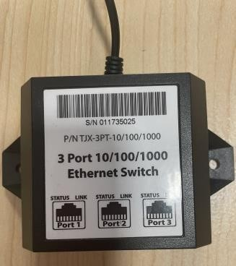

- De-install the Pin-Pad.
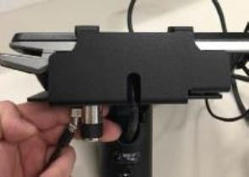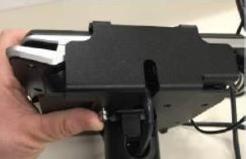

- Disconnect the security cable from the Pin Pad stand then remove the security screw & de-install the security plate.
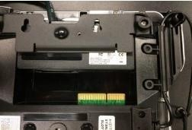

- To disconnect the Pin Pad, push down the two tabs to remove the I/O Module.
NOTE: The Pin Pad MUST be relocated with the Register it is connected to.

Disconnect the Register Call Forwarding Display

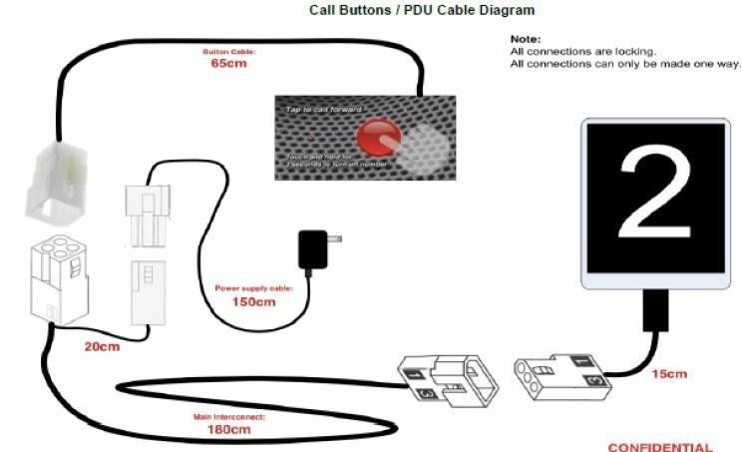

- Disconnect the power pack from the AC outlet

Disconnect the remaining register components/accessories.
- Disconnect the main Register power cord.
- Disconnect the Printer
- Disconnect the Keyboard
- Disconnect the All-In-One Display
- SAVE the security tethers, do not leave with old register counters

Re-Installation of Registers- SPACE POLES.

This includes New Flat Top (All-In-One) Register Counters and No Register Garage. The register is mounted on a space pole.

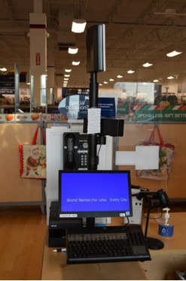

SPECIAL CONSIDERATIONS:
- Note that the Garages will not be used when the Engage Pro is re-installed on SPACE POLES, the garages are to be neatly stacked on a Pallet, ask the MOD where to put the pallet.
- The old VESA mount can be used when the new VESA mount sent with the space poles is the wrong size.

Line Conditioner – used at POS Registers
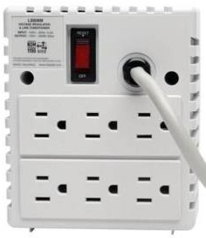
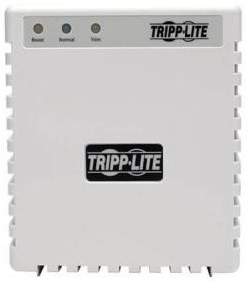

Line Conditioner Installation Procedure at POS Registers
- Install one line conditioner at each Register; Connect the Line Conditioner to a dedicate AC Outlet & connect only the Register to the Line Conditioner. Install a Line Conditioner at each Register including Jewelry Registers at TJ Maxx Stores.

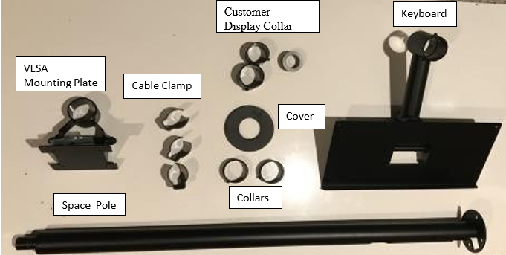

IMPORTANT: SEQUENCING OF REGISTERS MAY NEED TO BE REVERSED DURING RE-INSTALLATION.

Engage Pro Space Pole Drilling Specifications
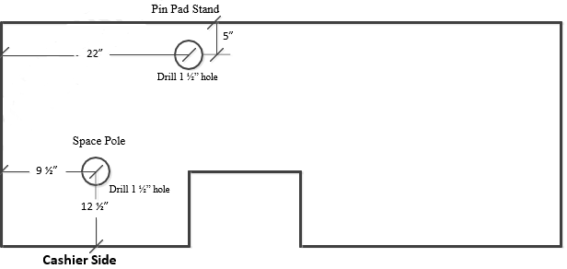

- Drill Holes in new flat register counters. Drill (2) 1 ½” holes as shown above at each counter.
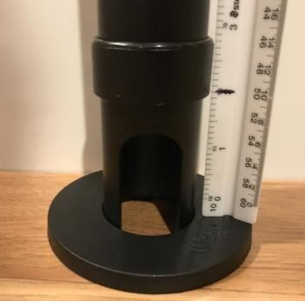

- Mount the Space pole.
Use 4 self-drilling pan head screws so the 2 openings on the pole are facing the Cashier side of the counter.

- Install the Space Pole cover
Install one of the collars at 2” above the Space Pole base & tight the collar to the pole
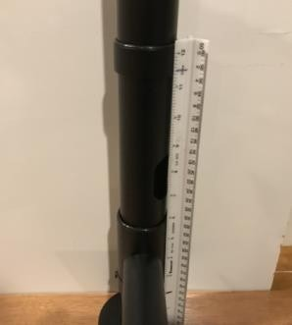
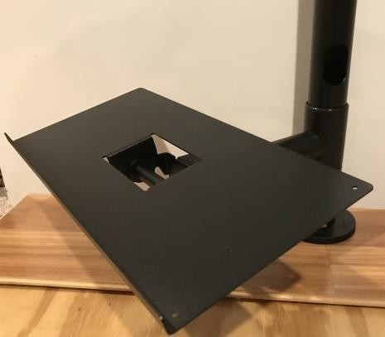

- Install the Keyboard tray onto the Space Pole.
- Install the second collar at 11 ½” above the Space Pole base & tight the collar to the pole.
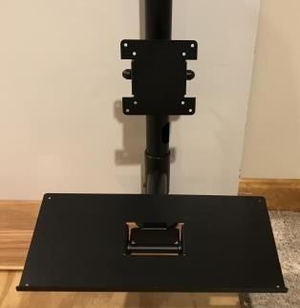

- Install the VESA Mount Plate onto the Space Pole
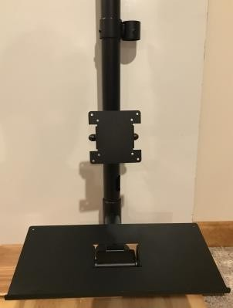

- Install the Customer Display Collar.
Install the customer display collar at 21 ½” above the Space Pole base & tight the collar to the pole.
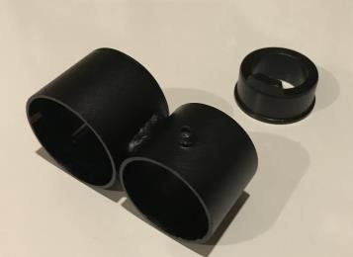

- Install the Customer display reducing plug into the top of the Customer Display Collar
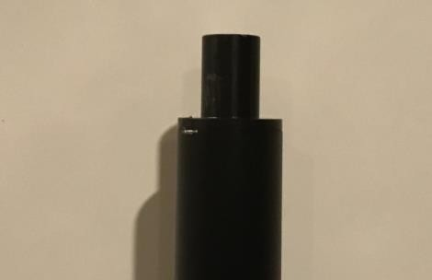

- Install the Call Forwarding Display reducing plug into the top of the Space Pole.

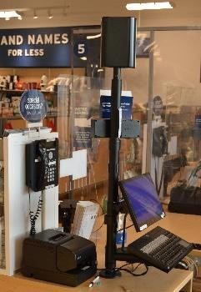
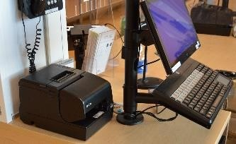

Route all Device Cable thru openings in
the Space Pole

Completed Space Pole Installation

Advanced I/O Module


Cash Drawer

Data
Reg #
 | 2 Data & 1 Voice cable | Data  Debit #
Voice
Xxxx

Note: HP Engage One Pro I/O Module will be located on top or behind the Cash Drawer

- Mount the HP Engage Pro onto the VESA mounting bracket.
Using the existing VESA mounting bracket, mount the Engage Pro on the Space Pole & feed the 2 cables thru the opening in the Space Pole. Use the cable clamps to secure the cables to the Space Pole.

- Install Printer & Scanner.
Install printer & scanner on top of the counter and feed the cables thru the openings in the Space Pole.

- Install the Keyboard & Customer Display.
Mount the keyboard and customer display on the Space Pole and feed the cables thru the openings in the Space Pole. Use the cable clamps to secure the cables to the Space Pole.

- Connect all devices to the HP Engage Pro I/O Module. Using the picture below, connect all devices as shown.
Note: The peripherals must be connected to the ports on the I/O Module as shown below or you will get errors when the Registers are powered up. Install the HP Engage Advanced I/O Module & connect all Peripheral cables as shown:

HP I/O Module Connections
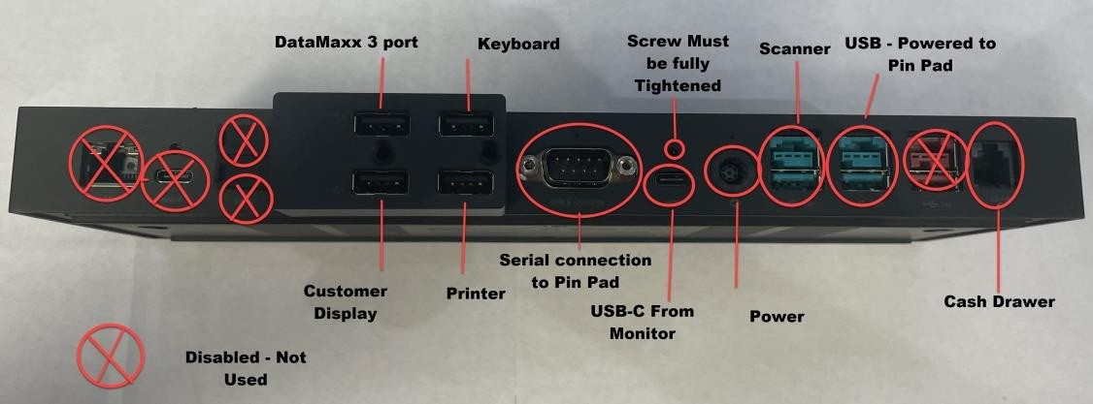

NOTE: You must make sure the cables are connected correctly per the display above. Failure to correctly plug in cables will result in equipment failure to the point it will need to be replaced, and extended onsite time

DataMaxx 3 port Ethernet Switch Installation

- Re-Install the DataMaxx 3 port Ethernet Switch
- Note, it may be easier to drop the 3-port switch from the top of counter to the bottom of the counter, Keeping the USB Plug where the I/O module will be installed.
- Route the USB power to the I/O modue.
- Connect the 3’ White CAT5 cable to Port 1 on the HUB and Connect to the RJ45 wall jack where the old cable was.
- Connect the Black CAT5 cable from the Register to Port 2 on to the HUB.
- Connect the 6’ Black CAT5 cable from the Pin Pad to Port 3.
- Connect the USB power to the I/O module.
- Connect the I/O Module to a dedicated AC Outlet and Power up the HP Engage Pro register.

The Register Should boot up to the store branded display:

Re-Installation of Registers- STANDARD
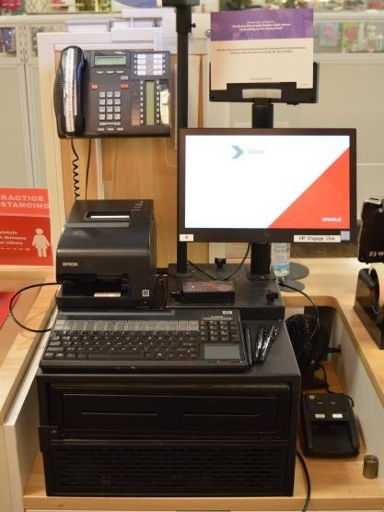

Counters with Wells to hold the Engage Pro Registers

- Relocate the Register, the Pin Pad, the Call Forwarding Display and ALL peripherals & cables to the new location.
- Connect cables to IO Module

Note: You must make sure the cables are connected correctly per the diagram below. Failure to correctly plug in cables will result in equipment failure to the point it will need to be replaced and extended onsite time. Make sure there is no dust in any of the connections before connecting.

HP I/O Module Connections

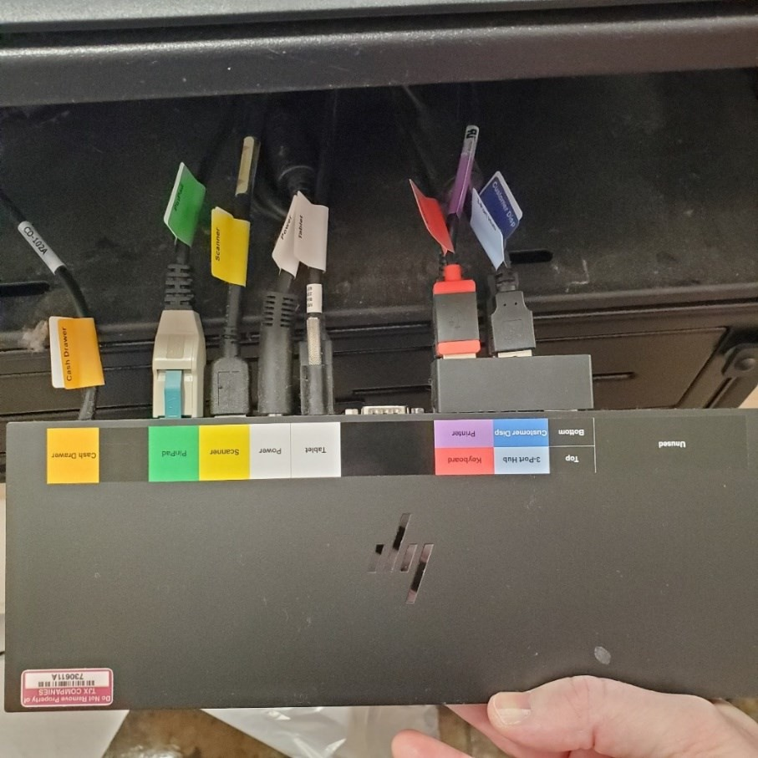

- Connect DataMax 3 port Ethernet Switch

- Install the DataMax 3 port Ethernet Switch
- Connect the DataMax USB cable to the I/O Module
- Connect the 3’ White CAT5 cable to port 1 on the HUB and Connect to the RJ45 Wall jack labeled Reg #.
- Connect the Black CAT5 cable from the HP Engage Pro to Port 2 on the DataMax
- Connect the 6’ Black CAT5 cable from the Pin Pad to Port 3 on the DataMax

- Reinstall the Pin Pad and Scanner
Important: ADA PIN PAD WEDGE STAND gets reinstalled at the Register closest to the front door
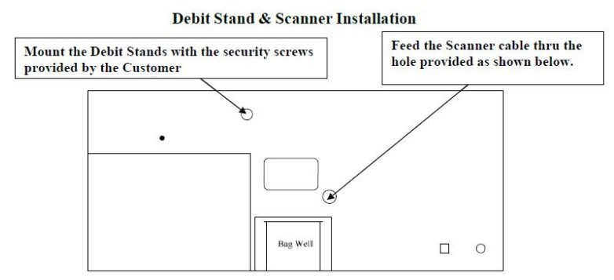

Drill a 1-1/2” hole in the side wall of the Register Well so you can route the Pin Pad cables to the Register
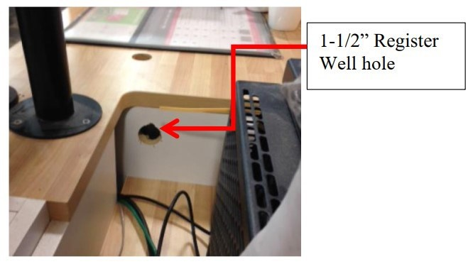

- Reinstall the Pin Pad & Register PC at the new location
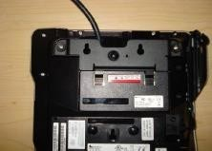
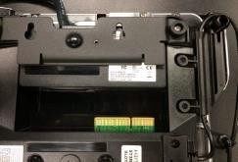

- Insert the I/O Module into the rear of the MX925, once inserted all the way, the 2 black clips will snap the module into place.
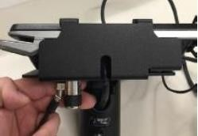
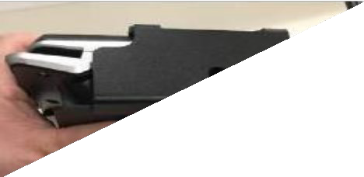

- Mount the Pin Pad on the Wedge or Swivel stand, Install and tighten the Kensington security screw thru the left side hole on the security plate, then reconnect the Security Cable Tether.

- Power Up the Register
The Register will boot up one of the following displays:

- Verify ALL Registers and Pin Pads are ONLINE
- Verify all Registers & Pin Pads are online
Call TJX CTC network group (855-859-2821 option 1, then option 1) & have them verify that all registers & pin pads are on the network. Provide the number of registers.
- Connect the Call Forwarding Display Power Pack and Verify that ALL call buttons and PDU are working properly.

Call Forward Systems

QBUSTER 2 Installation
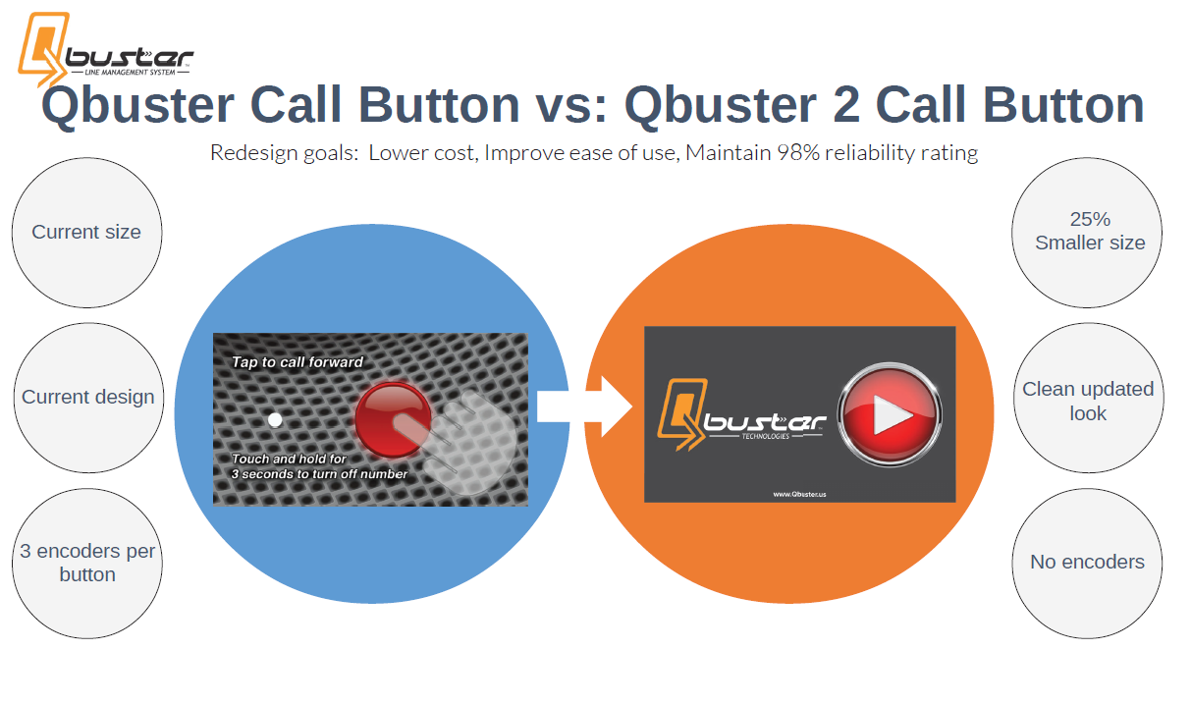
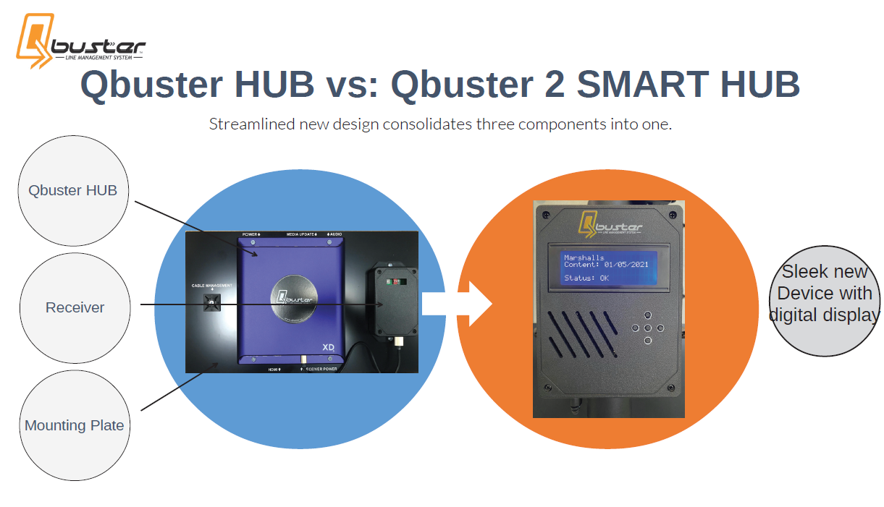



Scope of Work: Replace existing QBuster1 (QB1) with the new QBuster2 (QB2)
- Remove Main Display Unit (MDU) back cover & de-install the QB1 Controller Panel
- Disconnect the HDMI Monitor cable & the Speaker cable from the QB1 Controller Panel
- Remove the QB1 Controller & Receiver Plate from the MDU pole.

“Slide the QB1 plate up to remove it from the MDU Pole”
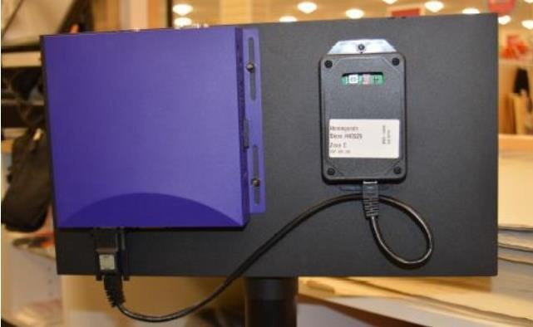
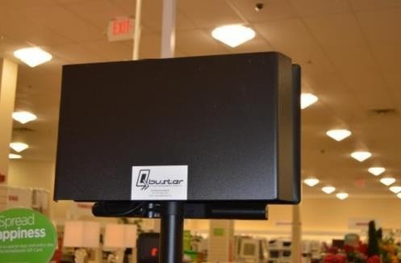

Back Cover QB1 Controller Panel

Note: Do not take the Controller & the Receiver off the plate, ship this as a whole unit

- Install the new QB2 Hub on the MDU pole
- Connect the Monitor HDMI cable & Speaker cable to the new QB2 Hub.
- Connect the power pack to the QB2 Hub, then connect power pack to AC outlet.
- QB2 Hub will take approximately 2 minutes to boot up.
- Verify the correct banner is displayed (TJ Maxx, Marshall’s, or HomeGoods) & monitor is displaying advertisement before continuing.

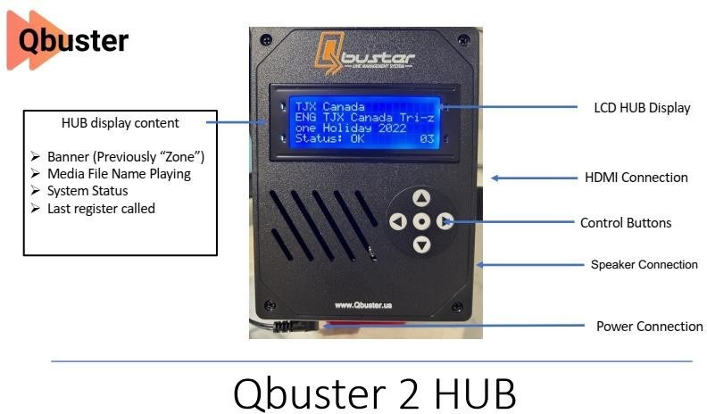

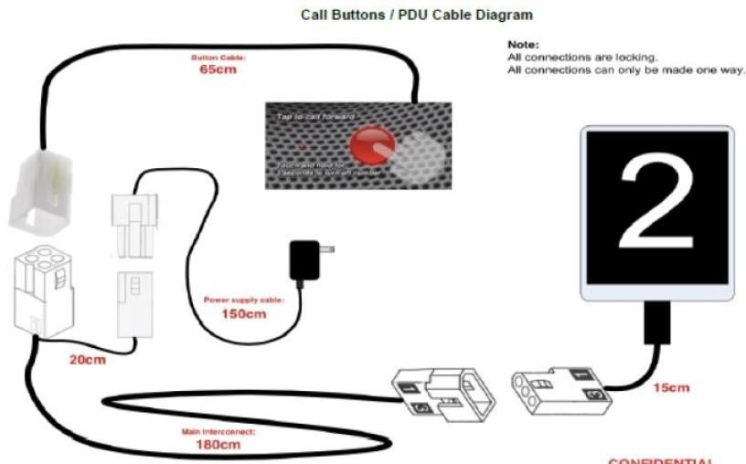
- At each register de-install the existing QB1 Call Button & power pack

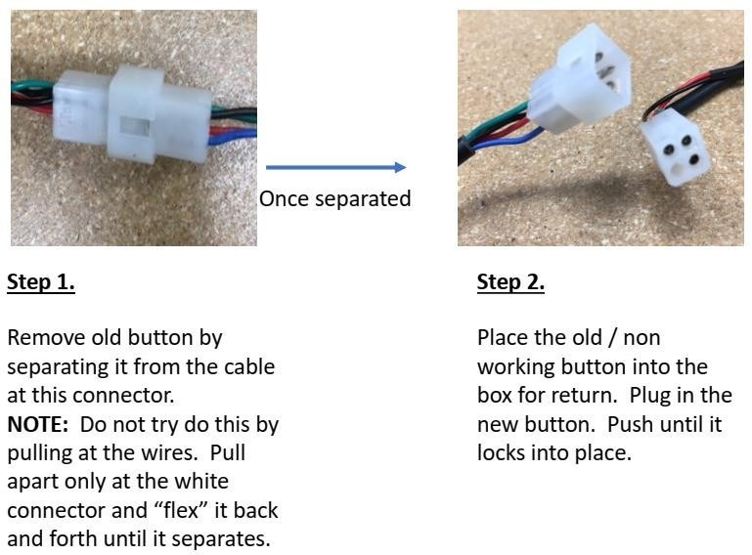

- Connect the new QB2 call button & new power pack at each Register location to the existing interconnect cable that is connected to the Register PDU display.

Note: new QB2 buttons are labeled with Register # on the back of the button
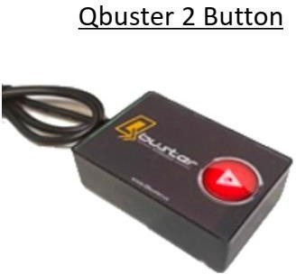

- Connect the power pack to an AC outlet. A green blinking LED should come on at the back of the call button.
- Test the call button at each register location to verify the main display unit displays & announces the register #.
- Box up all old Qbuster1 equipment (Hub Unit, Call Buttons, & Power Packs), & give the Store Management the box to ship back to Qbuster Tech
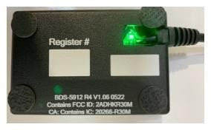

- Box up all old Qbuster1 equipment (Hub Unit, Call Buttons, & Power Packs), & give the Store Management the box to ship back to Qbuster Tech

DO NOT SEND THIS EQUIPMENT TO WHALLEY COMPUTER
Leave this address with store MOD for the old Qbuster equipment:
Qbuster Tech
28 Church Street Suite #2
Warwick, NY 10990 Attn: Iwona B.

QBUSTER 2 Call Forwarding MDU Installation
IMPORTANT: MDU (Main Display Unit) Installation is different depending on the type of Store and the type of register counter.
Read Work Order Description for what counter to install the MDU

- TJ Maxx and Marshalls Stores – MDU Installation (@ Register 2)
Register Well Counter:

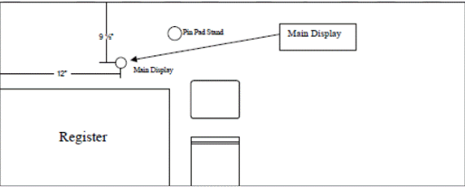
Drill a 2 1/8” hole for the MDU pole at 9 1/2” in from the front edge of the register counter & 12”
from the side edge of the counter.
- HomeGoods Stores – MDU Installation (@ Register varies, see WO)
Register Well Counter:

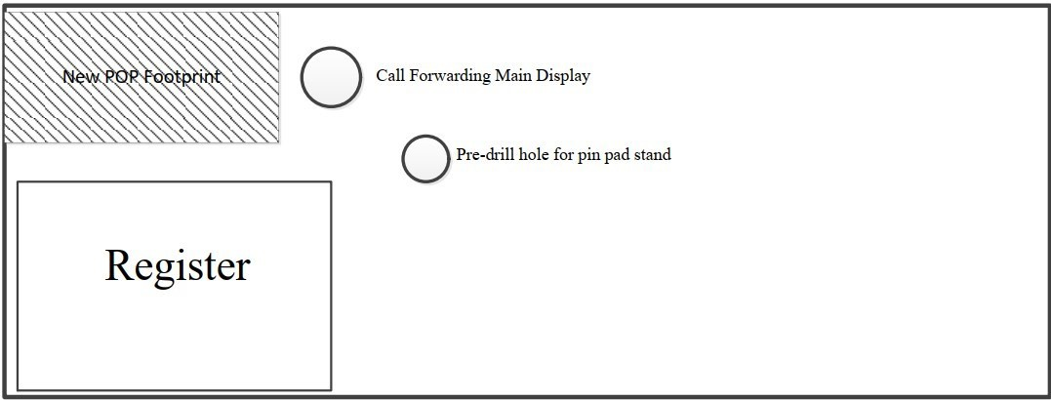
Drill hole so the
center of the Call Forwarding Main Display is 3” in from the front of the counter & 3” over from the POP.

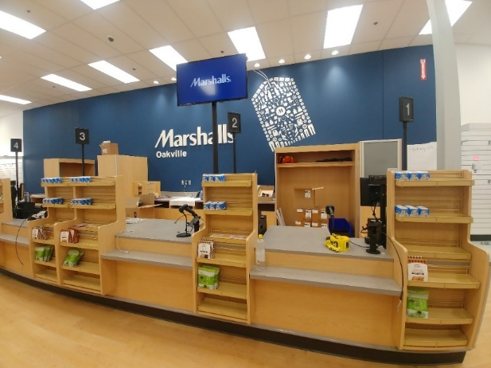
Final Assembly Photos

QBUSTER 1 Call Forwarding Installation
The WNS is delivered in 4 boxes (including the monitor). Tools and equipment that do not come with the system but are required for full installation.
Boxed Components:
• (1) CDU pole collar box
• (1) Control panel box (includes buttons)
• (1) Monitor/32” TV (provided by TJX)
• (1) Speaker bar (provided by TJX)
• (1) CDU pole box
• (1) Control panel cover
• (Varies) PDU poles = number of registers
• (Varies) PDUs = number of registers
• (1) Dual CDU kit (for +10 register stores only)

Installation Instructions:
CDU Pole
Objective: Install CDU Pole (Central display poles)
Quantity needed = 1 pcs
1. Locate the proper position for CDU pole
2. Use 2 1/8” drill bit and drill through countertop
3. Insert pole into drilled hole
4. Screw CDU pole flange to countertop
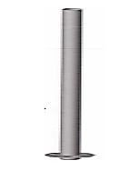
Note: Installer to provide 5 wood screws

CDU Pole Collar
Objective: Attach CDU

collar to video monitor
Quantity needed = 1pcs
1. Locate the video monitor box
2. Connect monitor to CDU pole collar using screws
contained in the video monitor box
3. Set onto the CDU pole
Note: Screws located in monitor box
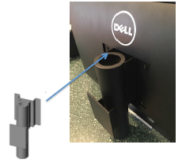

Control Panel
Objective: Attach Control Panel to Pole Collar
Quantity needed = 1 pcs
1. Attach pre-configured Control Panel to collar
2. Connect HDMI or DVI cables to monitor
3. Connect power cables and drop-down CDU pole
4. Plug in power supply to outlet
Note: Set black housing to cover back
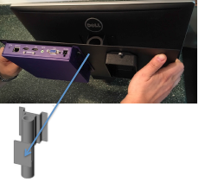

PDU Poles

Objective: Install PDU Pole (Position display poles)
Quantity needed = 1 per register
1. Locate proper position on register housing
2. Screw PDUs to register housing
Note: Installer to provide metal screws
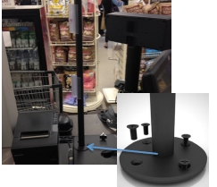

PDUs
Objective: Install PDUs (Position display units)
Quantity needed = 1 per register
1. Drop long power cable down PDU pole
2. Connect to button
3. Plug in power supply cable to outlet

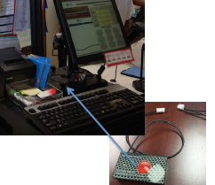
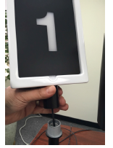

Call Buttons
Objective: Install Call Forward Buttons
Quantity needed = 1 per register
1. Connect button to port on PDU cable
2. Position on top of register housing
3. Press button to test and activate
Note: Must press button to illuminate PDU

CDU is placed between registers 1 and 2, or directly next to register 2 as seen in the photo below.

Dual CDU kit is all the hardware required to install a second CDU pole and monitor along with the necessary cables and equipment
Note: USB Content key should be attached to back of TV

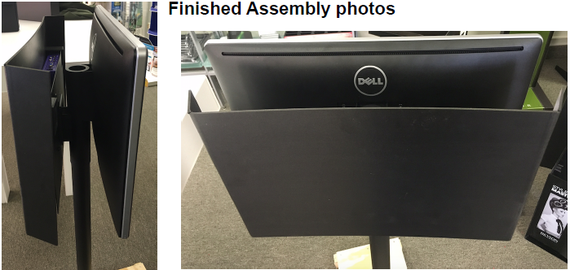

Frontline Phones:
Mount Telephones on the new Frontline POP’s
Note: Beige wire-mold comes in a roll & needs to be snapped together to form a channel

Note: All telephones must be mounted on the “POP” as shown, approximately 1” from the top & 1” from the left edge of the POP backboard so that the top tray of the POP will hide the screw when it penetrates the backboard.

- Mount all Nortel Telephone at each Register location on the “POP” unit using #8 – 1/2” screws. Drill a ½” hole in the counter at the base of the “POP” & install the Beige wire-mold to neatly route the telephone cable. Wire-mold should be 14” in length

- Shipping Address: all old telephones must be boxed up by the technician & shipped to the following address by the Store Management
Whalley Computer Associates
One Whalley Way
Southwick, MA 01077
Attn: TJX Depot (413) 569-4200

Install, Program, & test the new Nortel telephones as follows:

Note: Before starting the new telephone installation Call Joe DeFazio at 215-570-9799 to complete pre-installation programming

Note: Register #1 in the new MARMAXX configuration (TJ Maxx & Marshall’s) is starting at the register counter furthest from the front door

- Register #1: (Extension 299)
Install the new Nortel 7316 telephone (see Store Manager for the new telephone) at Register #1, program as X299 with the same features as X200 & verify extension & all keys are programmed correctly. (install new telephone label for x299)
- Register #2: (Extension 200)
Install the new or existing Nortel 7316, Extension #: 200 at Register #2 & verify extension & all keys are programmed correctly. (install new telephone label for x200)

Relocate Telephone & PF Jack to the new Cash Counter location (see Remodel Blueprint or Site Super for exact location): (Extension 201)
Install the new Nortel 7316T, Extension #: 201 on the back counter & cross-connect to existing X201 port on the telephone system.

Cross-connect the PF Jack (RED) to telephone #: To Line 1

Note: If a cable does not exist at the Cash Counter or any register location you will need to install one

Note: X200, X201, & X299 are the only telephones that should ring on incoming calls; all other frontline extensions should be display lines only

Jewelry Counter

General Notes
The Jewelry Counter can be renovated in 2 different ways, Jewelry Counter Adjustment and Jewelry Counter Move. Both options require a Queue Line Cutover style night where the register must be moved, set up and tested all in one night. Before moving anything take plenty of photos of where everything is.

Jewelry Counter Adjustment
This option will have the register moved from the center of the jewelry counter onto the outside counter closer to the customers.

Jewelry Counter Move
This option will have the entire Jewelry Counter being moved to a new location of the store and have the register set up the same as the Jewelry Counter Adjustment.

TRIPP LITE Power Conditioner & Line Conditioner
NOTE- Put UPS in bypass mode if Tripp lite is installed.
Please refer to appendix on how to put UPS in bypass mode depending on the type of UPS battery at the store.
Note: *Florida, Alabama, Mississippi, Oregan, PR, Texas, Washington – Keep the UPS and does not get TRIPP LITE power conditioners. These states will get battery replacements for the UPS*. Every other state will get TRIPP LITE power conditioners and UPS will be placed in bypass mode.
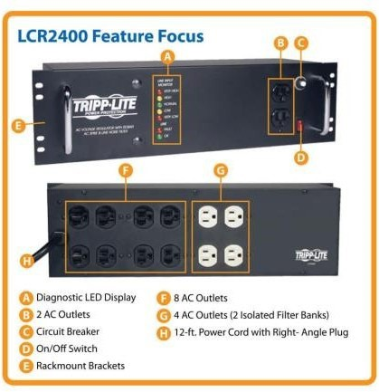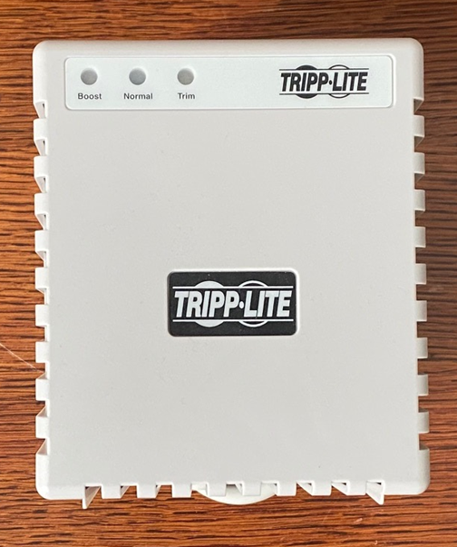
Rack mounted power conditioner:
- Locate a suitable location to mount the 3U power conditioner.
- Install rack mount unit into a non-IG (White) power outlet If possible.
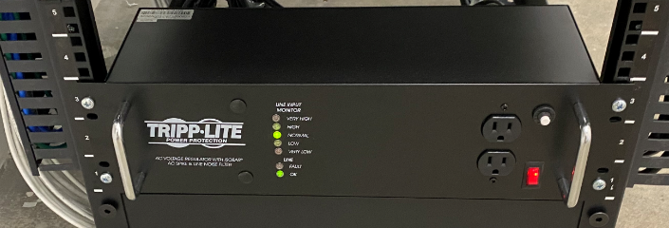

- Connect rack equipment to the new unit.
- Power on power conditioner.
- Confirm all systems equipment powers back on.
- Perform cable clean up as needed

APC power supply removal:
Note: not all stores being visited will have this unit installed.
- Remove 4 screws mounting APC to the rack.
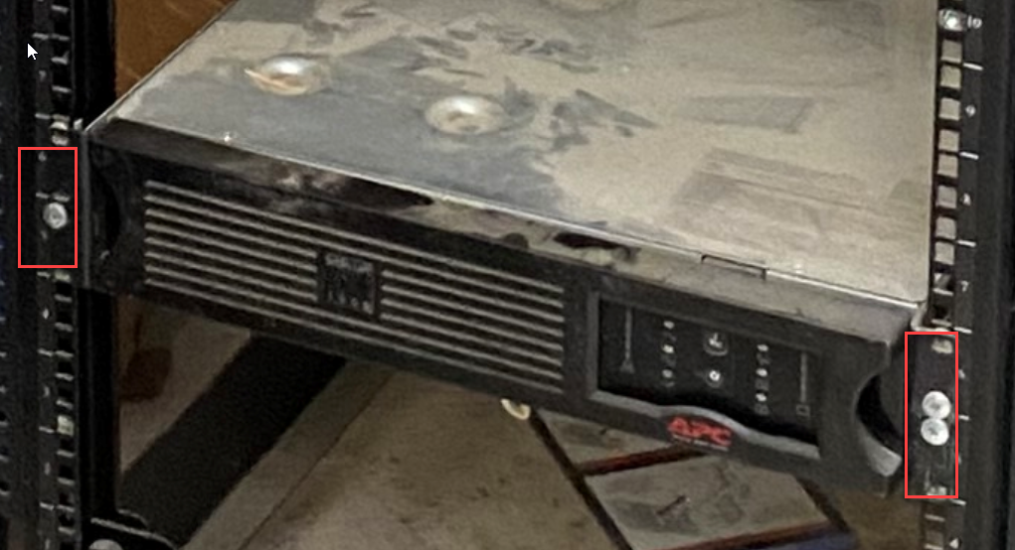
- Pull APC out of rack and place in shipping box for return shipping to depot.

Installation of register power supply:
- Shut down register.
- Remove power cables from IG (Orange) outlet and connect to new power conditioner.
- Plug new power conditioner to non-IG (White) outlet and turn on power conditioner.
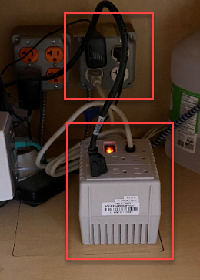
- Turn on register and confirm no errors occur.
Note if the register is an HP Engage Pro turn off printer prior to starting the register.
- Repeat steps 1-4 on all registers in the store.

Power Conditioner Installation Procedure at System Rack
- Install the power conditioner on the System Rack & mount to the rack if possible.
- Connect the Power Conditioner to a dedicated AC Outlet & power it on.
- Connect the 2 HP Servers to the Power Conditioner (White Outlets)
- Relocate the Servers 4 power plugs to the Power Conditioner.
- Disconnect 1 Server power cord, connect it to one of the White Outlets on the Power Conditioner & confirm the Server power supply GREEN light come back on.
- Repeat step 1 for all Server power cords.

UPS Battery Upgrade- replacement of existing batteries in UPS
- Identify which model of UPS is at the store. Depending on the model you can find the battery replacement procedure in Appendix.
(Oneac SEII, GXT3, GXT4, GXT5)
- Batteries for the GXT3 &4 are the same and are interchangeable. Batteries for the GXT5 are different and are not interchangeable.

Back Office System Installation

This section will cover:
- Managers Office
- Assistant Managers Office
- Cash Office
- Staff Lounge

When moving any parts of the please remember to label every part to ensure that nothing gets misplaced.

Step 1: Take a Photo of where everything is as you will be setting up everything the same or extremely similar as it was before.
Step 2: Label everything to ensure nothing gets misplaced
Step 3: Setup cable drops as required in new location
Step 4: Disconnect and move everything to its new location
Step 5: Reassemble and test equipment

Staff Lounge
The staff lounge is not changing with this renovation. But in some renovations, you may be required to move equipment around. This section documents that process.

Time Clock Tear Down & Set Up
This section shows how to move the time clock
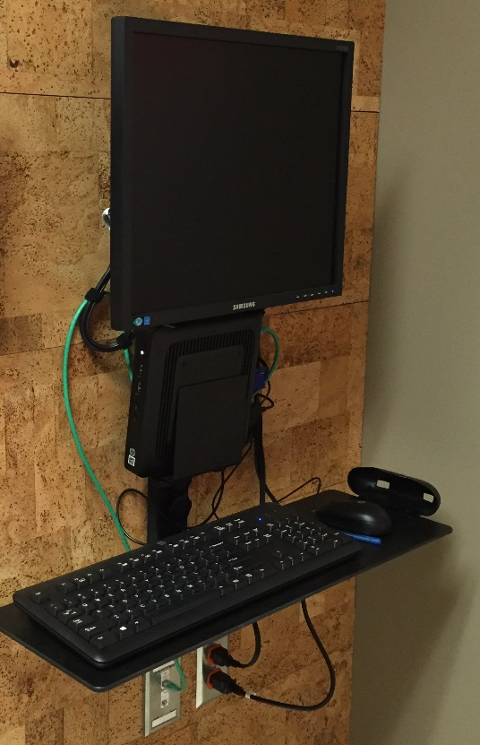

- Disconnect all power cables, network cables and peripherals
- Detach Thin Client and Monitor from bracket
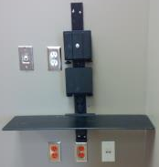
- Remove screws holding back support from wall

Drilling the Back Support
- Drill 2 holes at the top of the main support and 2 holes at the bottom with a 7/16th” drill bit (just like the pictures above)
- Gently twist the screws into the anchor with a screwdriver or cautiously with a drill
- Once fully screwed in, gently unscrew the screws from the anchors entirely

Setting it Up
- Use the screws provided with the bracket
- Connect the keyboard tray to the bottom of the bracket
- The thin client support in the middle
- The monitor support at the top
- Assemble the pieces together just like in the picture below

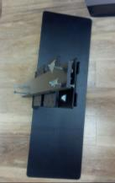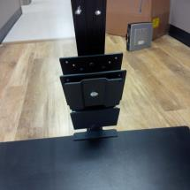

Mounting the Face Plate
- Using the screws and washers, mount the “face plate” to the inner 4 holes of the “back plate”
- Mount the assembled pieces to the wall at 5’ AFF just like in the picture below

- Unpack the HP Thin Client
- Attach the Thin Client on the bracket
- Connect all power cables.
NOTE: Asset tag must be visible.

Install Monitor
- Remove the stand from the monitor
- Mount the equipment holster from the top of the bracket to the back of the 17” HP Monitor
- Reattach the monitor to the top of the bracket; the monitor’s height should be set to the highest possible setting
- Connect the keyboard, mouse, monitor, power and network cables to the back of the Thin Client

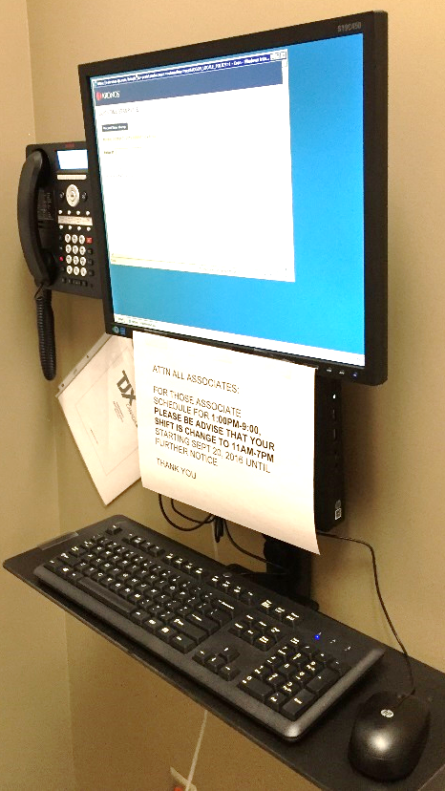

*Please note that the phone should not be placed beside time clock as per first image. *

- The installed equipment should look like the picture above
- If there are power outlets available, plug the equipment in but do not turn them on
- If there are no power outlets, be sure to make a note of this in the checklist

Network Connectivity

- Connect a 7’ blue patch cord to TC1 and power on thin client
- Ensure that the Kronos Thin Client can be pinged

Staff Lounge TV
- Relocate existing Training TV data jack to new location, install a Purple Jack. (label Training TV)
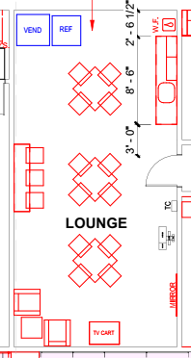

Project Closeout
- All garbage must be removed and disposed as per on site instruction from GC/site supervisor/store management team
- All boxes must be flattened and disposed accordingly
- Provide an inventory count of all remaining equipment/materials
- Take pictures of all equipment installed (must be a high-quality picture, both close up as well as far angle view) and also the general area of the following:
  - Frontline
  - Sales floor
  - Offices
  - Warehouse
  - Fitting room
  - Data room (multiple view of the data rack components)

Appendix:

Procedure for UPS manual Bypass

Liebert GTX3 and GTX4:

- Place UPS in Manual Bypass.
- From the main menu select Control then press enter.
- From the main menu select Control then press enter.
- Select TURN UPS BYPASS and press Enter. The UPS will transfer the connected loads to the internal bypass.
- Place UPS in Maintenance Bypass:
- Place the UPS on internal bypass. This may be done by either of the following methods:
- Refer to step 1 Manual Bypass.
- Slide the bracket away from the manual bypass breaker on the rear of the UPS. This requires loosening the captive screw and sliding the bracket up and away from the Manual Bypass breaker.
- Move the Manual Bypass breaker on the rear of the UPS to the bypass position. This requires loosening the captive screw and sliding the bracket up and away from the Manual Bypass breaker.
- Silence Audible Alarm.
- On the control panel arrow down to main menu and hit enter.
- Select 3 Control.
- Select 2 Alarm Control.
- Select 2 Audible Alarm Off.
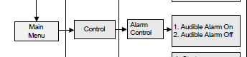

Liebert GTX5:

- Place UPS in Maintenance Bypass.
- Place the UPS on internal bypass. This may be done by either of the following methods.
- Place UPS in Manual Bypass.
- On the Control panel press enter button (5) to turn on the display (4).
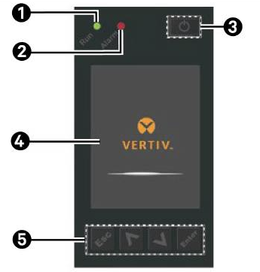
- Select TURN ON/OFF/to bypass and press Enter.
- The UPS will transfer the connected loads to the internal bypass.
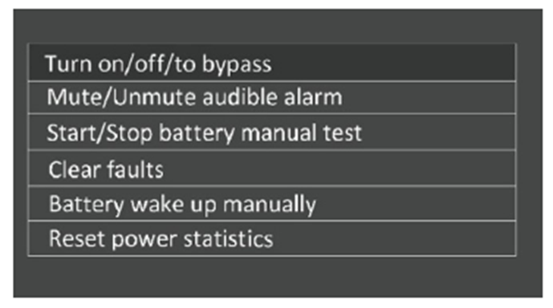
- Place UPS in Maintenance Bypass.
  - Slide the bracket away from the manual bypass breaker on the rear of the UPS. This requires loosening the captive screw and sliding the bracket up and away from the Manual Bypass breaker.
  - Move the Manual Bypass breaker on the rear of the UPS to the bypass position. This requires loosening the captive screw and sliding the bracket up and away from the Manual Bypass breaker.
- Silence Audible Alarm.
- On the control panel arrow down to main menu.
- Select Mute/Unmute audible alarm
- Press Enter to set alarm to mute

Oneac Synergy SEII:

- Use the Front panel to place the UPS into “Static Bypass”. The UPS cannot protect against power outages while the UPS is in static Bypass.
- UPS is in static Bypass
- Press the "Menu" button.
- Select Submenu "Control."
- Press "OK."
- Select Submenu "Turn UPS ON/OFF."
- Press "OK" The control panel displays "Turn UPS to Bypass".
- Press "OK" to switch off the inverter.
- The display should read "UPS Bypass Output" and the Bypass LED should be lit. At this time the unit(s) should be in Static Bypass.

UPS Battery Upgrade- replacement of existing batteries

Oneac SEII UPS
Scope of Work:
- BEFORE BEGINNING THE UPS BATTERY REPLACEMENT, VERIFY THE SITE HAS RECEIVED THE APPROPRIATE QUANTITY OF BATTERIES BEFORE POWERING DOWN ANY EQUIPMENT.
- Follow the TJX On-site procedures including providing the MOD with the proper security code.
- Inform the MOD that replacing the batteries should not affect the systems.
- Ask the MOD to stay off the systems during the replacement.
- Locate all the needed replacement equipment.
- Verify and document any systems issues prior to swapping batteries.
- Place the unit into Bypass. The UPS is located in the Electric room.
- Replace Oneac batteries.
- Take UPS out of Bypass, note if UPS has a LAN card installed & is it connected to the network.
- If the UPS is connected to the Network, disconnect the Data cable from the UPS
- Verify all systems are connected and working & have Store Management confirm proper operation.
- Call TJX CTC to confirm Network communications is up & operational.

Battery Replacement Procedure:
- Use the Front panel to place the UPS into “Static Bypass”. The UPS cannot protect against power outages while the UPS is in static Bypass.
- 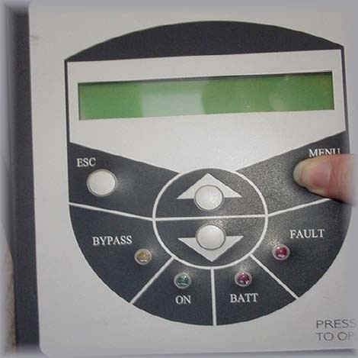
- UPS is in static Bypass.
- Press the "Menu" button.
- Select Submenu "Control."
- Press "OK."
- Select Submenu "Turn UPS ON/OFF."
- Press "OK" The control panel displays "Turn UPS to bypass”
- Press "OK" to switch off the inverter.

Complete Steps 7- 18 for each unit that is having batteries replaced
- The display should read "UPS Bypass Output" and the Bypass LED should be lit. At this time the unit(s) should be in Static Bypass.
- Ensure that the display is latched in the out / extended position. This will make it easier to remove the front cover.
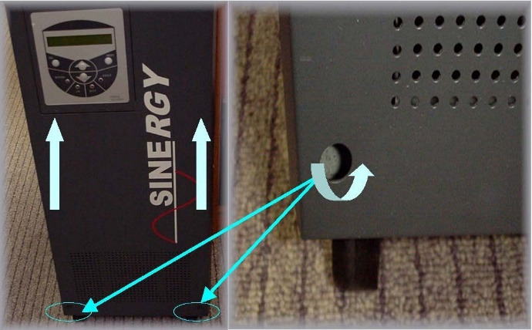

- Remove the two (2) screws in the bottom of the front cover. Locate the screws as per the picture above.

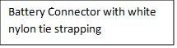
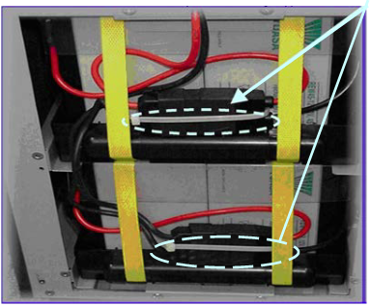
- Lift the front cover plate up and off of the unit. Place it aside in a safe location.
- Cut and remove (if present) white Nylon Tie Strap around battery connectors, circled in photo above. Strap is used to keep battery plug together during shipping and not necessary after final installation.

Upper battery retention plate
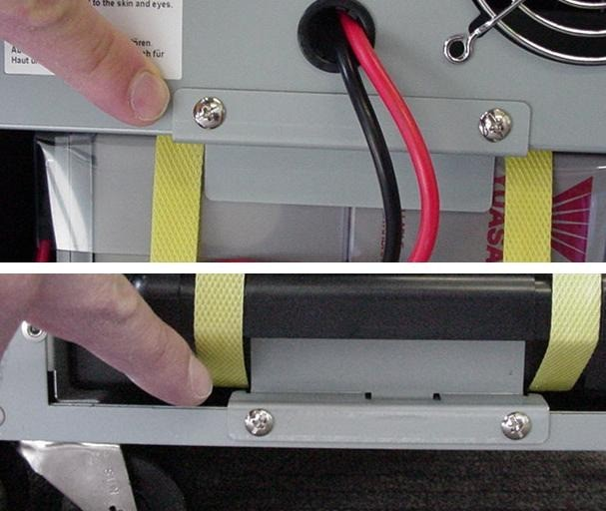
Lower battery retention plate
- Remove two (2) screws from each upper and lower battery retention plates, remove plates and lay them aside for reinstallation later.
Note: Battery pack is heavy. Use two hands when removing pack from unit.
- Disconnect the battery connectors and slide them out through the yellow strapping to get them out of the way.
- Slide out the battery pack.
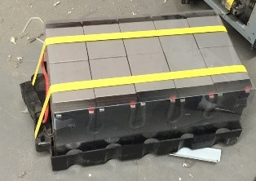
Note: Individual batteries are shipped to the stores. They are not assembled in a tray.
Disconnect the old batteries and remove them from the tray. Place the replacement batteries in the tray and reconnect.

- Slide in replacement battery pack.
- Slide battery connectors back thru the yellow strapping and re-connect the battery connectors. Ensure proper connection.
- Re-attach upper and lower battery retention plates with two (2) screws each
- Reinstall front cover plate and two (2) retention screws. To place UPS back online complete steps 19-25.
- Press the "Menu" button.
- Select Submenu "Control."
- Press "OK."
- Select Submenu "Turn UPS ON/OFF."
- Press "OK" The control panel displays "Turn UPS to Online"
- Press "OK" to switch the inverter on.
- The green "ON" LED should be illuminated and the UPS should be in "Online" operation.
- Box-up the old batteries & attach the provided shipping label. Technician should call Fed-Ex for pickup of equipment prior to leaving site. Give manager old equipment.
Correct switch settings:
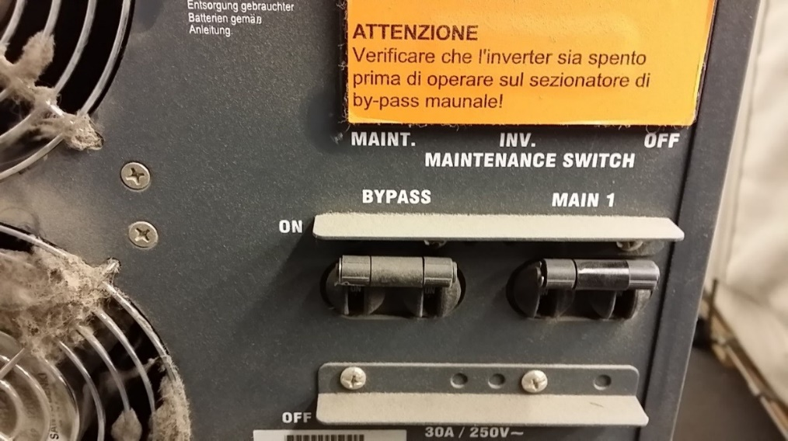

Troubleshooting
The following steps should be taken if one of the following issues occurs.
IF UPS Batteries are swollen.
If UPS is already in bypass with a fault.
If UPS will not go into bypass mode.
If UPS cannot be taken out of Bypass mode.
- Battery is swollen, cannot remove.
    - Leave batteries in unit. Do NOT attempt to remove.
    - Ship new batteries back to sender.
    - Contact your PM.

- UPS in Fault, Bypass, or will not go into Bypass.
  - Call manufacturer to troubleshoot: Oneac- 800-369-7179 option 1
Tech support will run through troubleshooting, troubleshooting may require powering down the unit, therefore should not take place less than 60 minutes prior to store opening, as all supported equipment will need to be rebooted.
If successful in clearing the fault/bringing unit out of bypass, replace the batteries as planned
  - If unable to clear fault contact your PM
Return new batteries to sender.

LIEBERT UPS Battery Upgrade- replacement of existing batteries in Liebert UPS
Note: Do not use Power Drills to remove or tighten the screws.

- Locate the replacement batteries (shipped directly to the store) There should be 2 trays with 6 batteries in each tray. Save the packing materials for the return of the existing batteries.

- Locate the Liebert UPS (usually located in the electrical room) and prepare for battery replacement. However, this could be by the electrical panel in a back Hallway.
- Identify the Model of your UPS and follow these instructions.
- Pack old batteries and place return shipping label on the box and call FedEx to schedule a pickup.
- For troubleshooting fault errors on the UPS follow the Troubleshooting instructions
- Report all outstanding issues with your Project Manager or your Company Point of Contact.

GXT3
NOTE: The Liebert GXT3 is designed to allow the user to replace the internal battery pack safely. The internal battery pack is hot-swappable. However, caution should be exercised because during this procedure the load is unprotected from disturbances and power outages.
Do not replace the battery while the UPS is in Battery Mode. This will result in a loss of output power and will drop the connected load.

These are general instruction on how to replace the batteries in the GXT3. You will be replacing the 2 battery packs in the External Battery Cabinet:
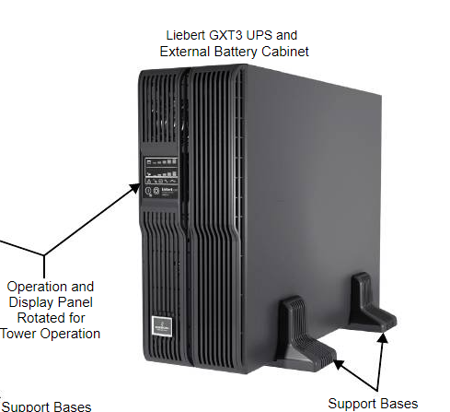

Battery Replacement Procedure:

- Remove the front plastic bezel cover from the UPS.
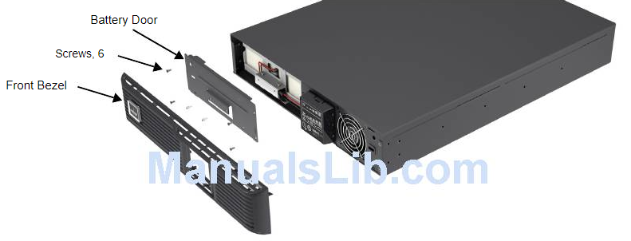
- Remove the 6 screws on the battery door.
- Lay the battery door and screws aside for reassembly.
- Pull the battery wires out and disconnect the battery plugs and battery receptacles
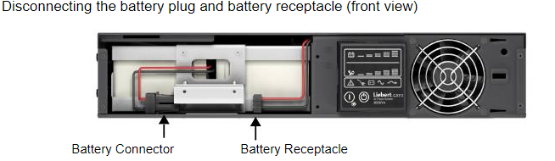

- Grasp the battery handle and pull the internal battery pack out of the UPS.
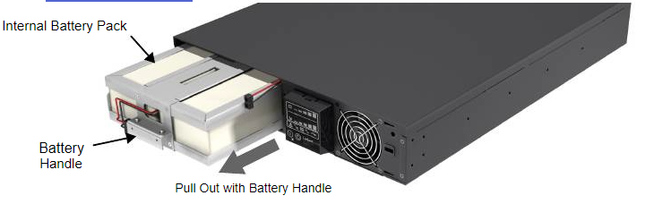

- Unpack the new internal battery pack. Take care not to destroy the packing.
Compare the new and old internal battery packs to make sure they are the same type and model.
If they are the same, proceed with Step 5; if they are different, stop and contact your Project Manager or Tech Support.
- Line up and slide in the new internal battery pack.
- Reconnect the battery plug and battery receptacle
- Gently push the battery wire and internal battery pack back into the UPS.
- Reattach the front battery door with the six screws.
- Reattach the front plastic bezel cover to the UPS.

Packing Old Batteries:
- Place the Old batteries in the box the new batteries arrived in.
- Place the return shipping label on the box and tape the box, Call FED EX (800 GOFEDEX) to schedule a PICKUP.
- Ask Store Manager where they would like you to put the return package. DO NOT leave the batteries in the Equipment room.
- If the box is damaged beyond use report to your Project Manager.
- If missing the return shipping label, the store can create a new one. Batteries will return to;
TJX Depot
1 Whalley Way
Southwick, MA 01077

Troubleshooting
The following steps should be taken if one of the following issues occurs.
- Battery is swollen, cannot remove.
- Leave batteries in unit. Do NOT attempt to remove.
- Ship new batteries back to sender.
- Contact PM for any issues.

- If UPS is in Fault mode
- Call manufacturer to troubleshoot: Liebert- 800-222-5877 option 1.
- Tech support will run through troubleshooting and may require powering down the unit. DO NOT power the unit down if there is less than 60 minutes before store opening because all supported equipment will need to be rebooted and you will need the time to complete all the reboots needed.
- If successful in clearing the fault/bringing unit out of bypass, replace the batteries as planned.

- If unable to clear fault contact the PM and return the new batteries to sender:
TJX Depot:
1 Whalley Way
Southwick, MA 01077

GXT4
CAUTION: Risk of explosion if battery is replaced by an incorrect type. Dispose of used
batteries according to the instructions.
NOTE: The internal battery pack is hot-swappable. However, caution should be exercised because during this procedure the load is unprotected from disturbances and power outages. Do not replace the battery while the UPS is operating in Battery Mode. This will result in a loss of output power and will drop the connected load.
NOTE: These are general instruction on how to replace the batteries in the GXT4. You will be replacing the 2 battery packs in the External Battery Cabinet.

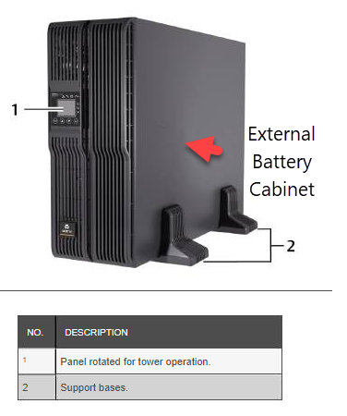

- Remove the front plastic bezel cover from the UPS.
- Loosen and remove the screws on the battery door
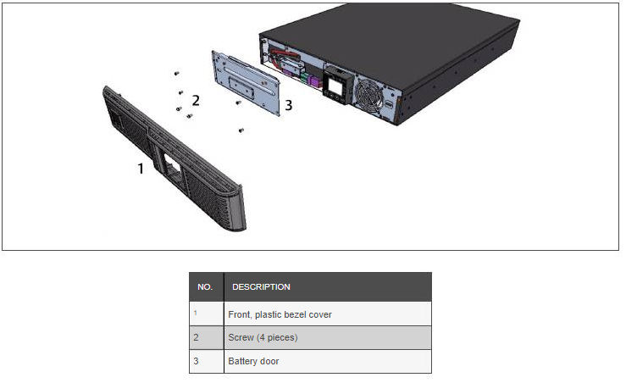
- Lay the battery door and screws aside for reassembly.
- Gently pull the battery wire out and disconnect the battery plug and battery receptacle
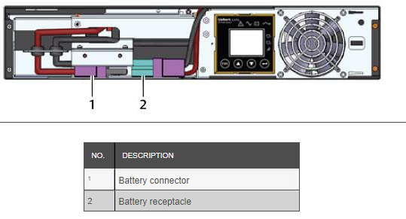
- Grasp the battery handle, and pull the internal battery pack out of the UPS
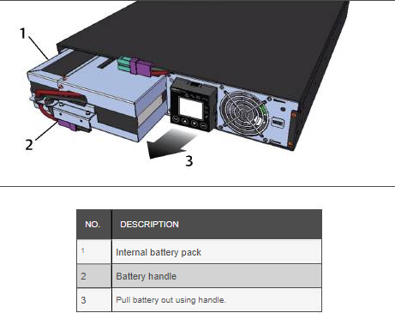
- Unpack the new internal battery pack. Take care not to destroy the packing.
Compare the new and old internal battery pack to make sure they are the same type and
model. If so, proceed with 7. If they are different, stop and contact your Project Manager or
Technical Support.
- Line up and slide in the new internal battery pack.
- Reconnect the battery plug and battery receptacle.
- Push the battery wire and internal battery pack back into the UPS.
- Reattach the front battery door with the 6 screws.
- Reattach the front plastic bezel cover to the UPS.

Packing Old Batteries:
- Place the Old batteries in the box the new batteries arrived in.
- Place the return shipping label on the box and tape the box, Call FED EX (800 GOFEDEX) to schedule a PICKUP.
- Ask Store Manager where they would like you to put the return package. DO NOT leave the batteries in the Equipment room.
- If the box is damaged beyond use report to your Project Manager.
- If missing the return shipping label, the store can create a new one. Batteries will return to;
TJX Depot
1 Whalley Way
Southwick, MA 01077

Troubleshooting
The following steps should be taken if one of the following issues occurs.
- Battery is swollen, cannot remove.
- Leave batteries in unit. Do NOT attempt to remove.
- Ship new batteries back to sender.
- Contact PM for any issues.

- If UPS is in Fault mode
- Call manufacturer to troubleshoot: Liebert- 800-222-5877 option 1.
- Tech support will run through troubleshooting and may require powering down the unit. DO NOT power the unit down if there is less than 60 minutes before store opening because all supported equipment will need to be rebooted and you will need the time to complete all the reboots needed.
- If successful in clearing the fault/bringing unit out of bypass, replace the batteries as planned.
- If unable to clear fault contact the PM and return the new batteries to sender:
TJX Depot:
1 Whalley Way
Southwick, MA 01077

GXT5
NOTE: The internal battery pack is hot swappable. However, you must exercise caution because; during this procedure, the load is unprotected from disturbances and power outages. Do not replace the battery while the UPS is operating in Battery Mode. This will result in a loss of output power and will drop the connected load.
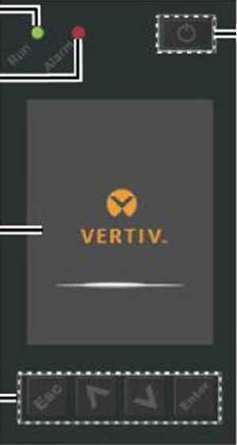

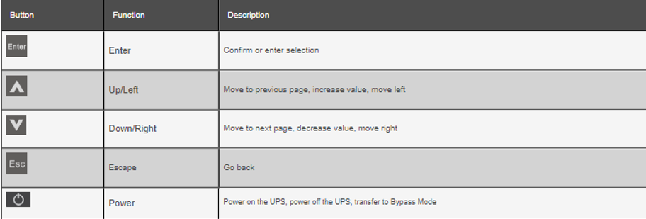

- Press the buttons on both sides of the UPS front panel and pull the panel. Open.
- Loosen and remove the screw from the battery door.
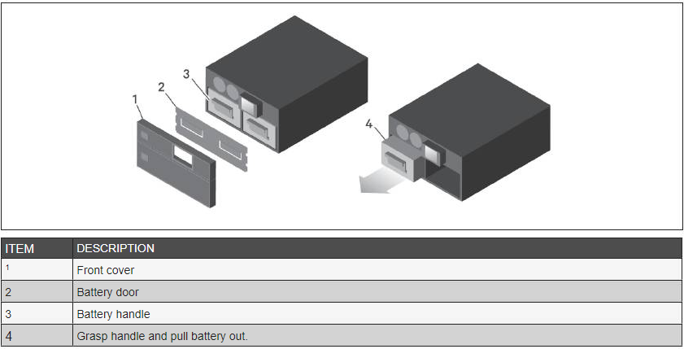
- Lay the battery door and screw aside for reassembly.
- Grasp the battery handle and pull out the battery pack.
- Unpack the replacement battery pack, taking care not to damage the packaging to re-use when disposing of the old battery.
- Compare the new and old battery pack to make sure they are the same type and model. If so, proceed with step 7. If they are different, stop and contact your Project Manager, or Technical Support.
- Line-up and slowly push-in each replacement battery pack. until 2/3 of the length is in the bay, then lift up and continue to push smoothly until the battery pack is fully inserted in the bay. The battery is fully inserted if the battery door fits flush against the UPS.
- Re-attach the battery door with the screw and replace the front cover.
- Activate the new battery pack(s) using the operating/display panel
- From the main menu, select Settings, then the Monitoring tab and verify that the date and time are correct. If the date or time need correction, see Setting the Date and Time Below
- Select the Battery tab, use the arrows to select Replace Battery, and press Enter. The replaced battery packs are activated.
- Use ESC to return to the main display.
Packing Old Batteries:
- Place the Old batteries in the box the new batteries arrived in.
- Place the return shipping label on the box and tape the box, Call FED EX (800 GOFEDEX) to schedule a PICKUP.
- Ask Store Manager where they would like you to put the return package. DO NOT leave the batteries in the Equipment room.
- If the box is damaged beyond use report to your Project Manager.
- If missing the return shipping label, the store can create a new one. Batteries will return to;
TJX Depot
1 Whalley Way
Southwick, MA 01077

Troubleshooting
The following steps should be taken if one of the following issues occurs.
- Battery is swollen, cannot remove.
- Leave batteries in unit. Do NOT attempt to remove.
- Ship new batteries back to sender.
- Contact PM for any issues.

- If UPS is in Fault mode
- Call manufacturer to troubleshoot: Liebert- 800-222-5877 option 1.
- Tech support will run through troubleshooting and may require powering down the unit. DO NOT power the unit down if there is less than 60 minutes before store opening because all supported equipment will need to be rebooted and you will need the time to complete all the reboots needed.
- If successful in clearing the fault/bringing unit out of bypass, replace the batteries as planned.
- If unable to clear fault contact the PM and return the new batteries to sender:
TJX Depot:
1 Whalley Way
Southwick, MA 01077

