Marshals M1121–
Scope of Work – Technician Checklist – IT Remodel

Frontline Cut-Over – New Millwork
SCHEDULE:
2 Night Scope – 12 Registers
- 1 new registers being added – Current frontline is 11 registers - Moving to 12 – 2 Registers on first floor new register added here; 10 Registers on second floor (main frontline)
- Pre-wire 59 data drops in support of frontline cutover and switch migrations (24 Registers; 2 Temp Registers; 1 Call Forward; 12 Back office; 10 Corporate; 6 AP Wlan; 2 EMS; 2 LP office)
- Disconnect and pull back existing register data runs, run pre-staged lines to register locations
- Disconnect and pull back existing voice runs for redeployment designated registers (Technician Note: Make sure when millwork is being installed that phone terminations are not trapped under new millwork)
- Removal of existing garage registers from old millwork – maintain components to each
- Uninstall Call forward poles with monitor 1 per night from millwork
- Front line POS data box, faceplates brough up to standard in new millwork
- 2 Data and 1 Voice for each register
- Add 2 TR ports at 1 and 10
- Add CF future port between register 2 and 3
- Conversion and installation of registers from garage to space pole mounting
- Installation of call forward system – including upgrading to the QB2 system including HDMI wireless receiver on second call forward display and remounting on millwork
- Installation of wall mounted phones onto pop display on millwork – use new wire mold
- QB1 Return will be separate from other devices to be returned to depot, box and attach supplied return label and give to manager for return
- Equipment return

Equipment List
- Complete Register Build for Reg 12
- Register 12 Nortel Phone
- Register Space Pole Kits x 11
- Box Cat6 x 20
- Cash Drawer Cable Clamp x 12
- Data Boxes / Face Plates / Termination Data Jacks to Frontline standards
- Telephone line wire mold x 12

Documents
- TJX US Store System Vendor Guide v1.0
- Cash Drawer Security V1.3
- Wire Specs ALL Chains 12_06_24.pdf

Debrief Take-Aways / Questions

Front Line Lessons Learned
- Ensure cabling termination aligns both at patch panel and termination end points.
- Label cable ends prior to disconnection that will be reused or used for new data runs
- Coordination with all onsite teams is key. Establish everyone’s roles and responsibilities and understand timing of project phase executions.
- Example: Coordinating cable termination and power installations with electricians
- Schedule tasks to be completed while other contractors executing prior project steps
Ex: Disassembling garage registers and conversion to new flat counter while millwork is being installed

Lounge – TV Wall Mount
SCHEDULE:

- Add additional Data Run for TV wall mount location
- Mount new 43” Lounge TV and Mood media player on wall

Equipment List
- Standard wall mount and applicable hardware
- Media player bracket mount and applicable hardware

Documents
- MMX Wall Mounted Lounge TV Install Guide V1.0.3

Debrief Take-Aways

Managers Office
SCHEDULE:
- Removal of thin clients and relocation of data boxes at the GC request

Equipment List

Documents
- Wire Specs ALL Chains 12_06_24.pdf

Debrief Take-Aways

Data Room
SCHEDULE:
- Replacement of non-standard patch cables
- Clean up data rack – remove excess cable
- Any Prewiring for Front end/register cutovers should be patched into newly installed patch panels prior to cutover night.
- Install 48 port patch panel for H switch patch required POS/Back office/Corp/Wlan cables
- Move H switch from IDF rack into MDF Rack patch into patch panel 6 registers max for each switch
- Install 48 port patch panel for H2 switch patch required POS/Back office/Corp/Wlan cables
- Move H2 switch from IDF rack into MDF Rack patch into patch panel 6 registers max for each switch.
- Run 2 data drops to EMS panel in MDF and terminate with blue keystone in a biscuit jack at EMS Panel (label EMS 2/3) - can be completed during prewire
- Terminate EMS runs into store profile patch panel and patch into H or H2 in available ports (Ports 26-35) - can be completed during prewire
- Data Rack cleanup – Equipment positioning
- Properly mount all network equipment into the Rack

Equipment List
- TJX standard color-coded patch cables (Cabling)
- 48 port patch panel x 2
- Box Cat6 x 1(Cabling) - EMS Drops
- Biscuit Jack x 2(Cabling) -EMS Drops
- Blue Keystone x 2(Cabling) -EMS Drops

Documents
- Wire Specs ALL Chains 12_06_24.pdf

Debrief Take-Aways
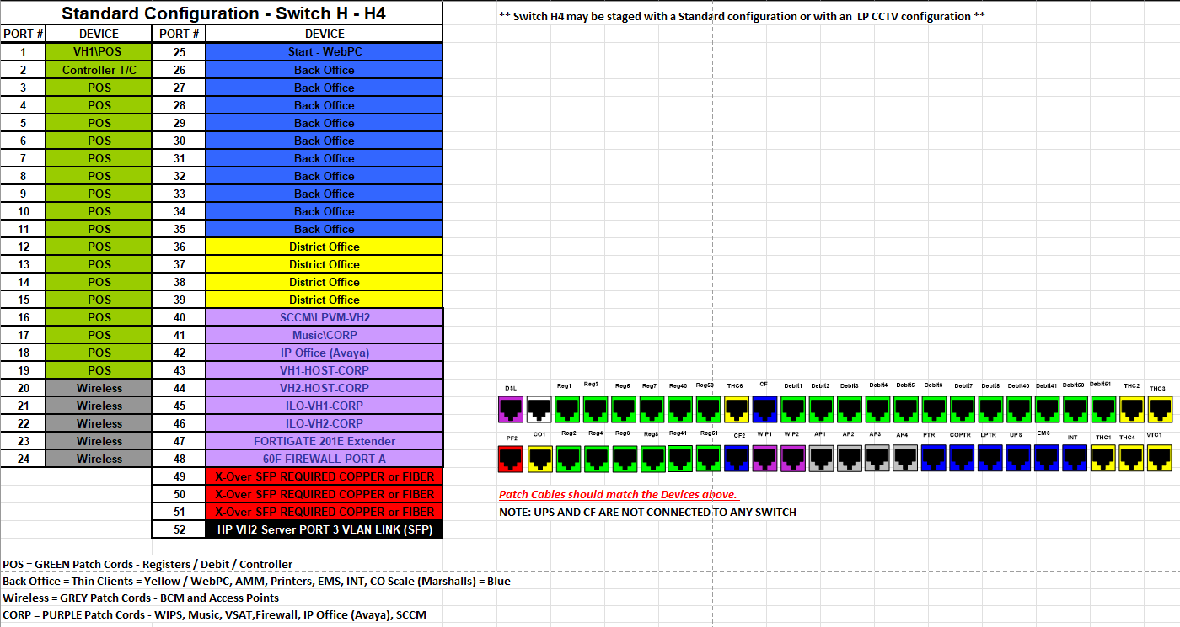

LP Office
SCHEDULE:

Equipment List

Debrief Take-Aways / Questions

Documents

Sales Floor & Fitting Room & Warehouse
SCHEDULE:

Equipment List

Debrief Take-Aways / Questions

Documents
- TJX US Store System Vendor Guide v1.0

Camera Add Ons
SCHEDULE:

Equipment List

Documents

Debrief Take-Aways

Additional Installation Notes:

During cleanup any addition cable or supplies not utilized during install can be taken from site by technician or disposed of in approved disposal location

Scope of Work – Technician Checklist – Full IP Conversion

Cabling/Wiring
SCHEDULE:
Overall
CCTV CAT6 60 Data Runs & 4 QTY 18/2 Power Runs
46 Cameras – 1 data run per camera (46)
1 Washroom Hallway 21” PVM (1 data run) (1)
1 Entrance 32” PVM (1 data run) (1)
1 Mullion Camera (1)
2 Footwear 32” PVM – with 2 data run (1 PVM and 1 Encoder) (4)
1 Queue line 32” PVM – with 2 data run (1 PVM and 1 Encoder) (2)
5 Covert Runs (5)

- Move H5 from LP IDF to MDF and mount in MDF rack
- Contact command center / NOC to ensure H5 switch is showing online
- Install 2 48 port loaded patch panels into Data Rack for H5 and H6
- Install H5 switch into Data room MDF in line with patch panel per TJX Standard.
- Remove PVM power supply from LP office and install it and the additional provided PVM Power Supply into MDF
- Run 4 18/2 Power cables to MDF and patch to PVM Power supplies
- Terminate all camera runs into patch panels
- Label patch panel jacks and patch cameras into H5 switch in MDF
- Capture serial number of new H6 switch and report to NOC for proper switch profile to be imported to the device
- Install new H6 switch into Data room MDF in line with patch panel per TJX Standard.
- Contact command center / NOC to ensure H6 switch is showing online
- Label patch panel jacks and patch in remaining cameras
- Removal of old cameras and replacement of ceiling tiles once cameras verified
- Old data lines for removed or cut back into suspended ceiling at camera end
- Old data lines removed or cut back so not visible at LP Office
- Install cameras across the store following the camera roll out schedule (Terminate camera end of run to a RJ45 male connector for all camera connections and a 1 port biscuit jack for Covert runs)
- Uninstall analog camera encoders from LP IDF add to equipment return
- Decommission LP IDF rack and dispose onsite or remove from site
- Verify link lights on the switch and contact command center to import and check viewing
- Frontline may require direct replacement due to same positioning of new cameras
- Prepare old cameras, mounting hardware and IDF for equipment return

Equipment List
- Cameras and mounting as per LP schedule
- Box Cat6 x 20(Cabling)
- 18/2 Cable Box x 2
- 48 Patch Panel X 2
- Keystone Black X 5
- PVM Power supply X 1
- 1 port biscuit jack X 5
- RJ45 Male connector X 46 – technician note if you would like to supply your own due to ease of use you are authorized to do so
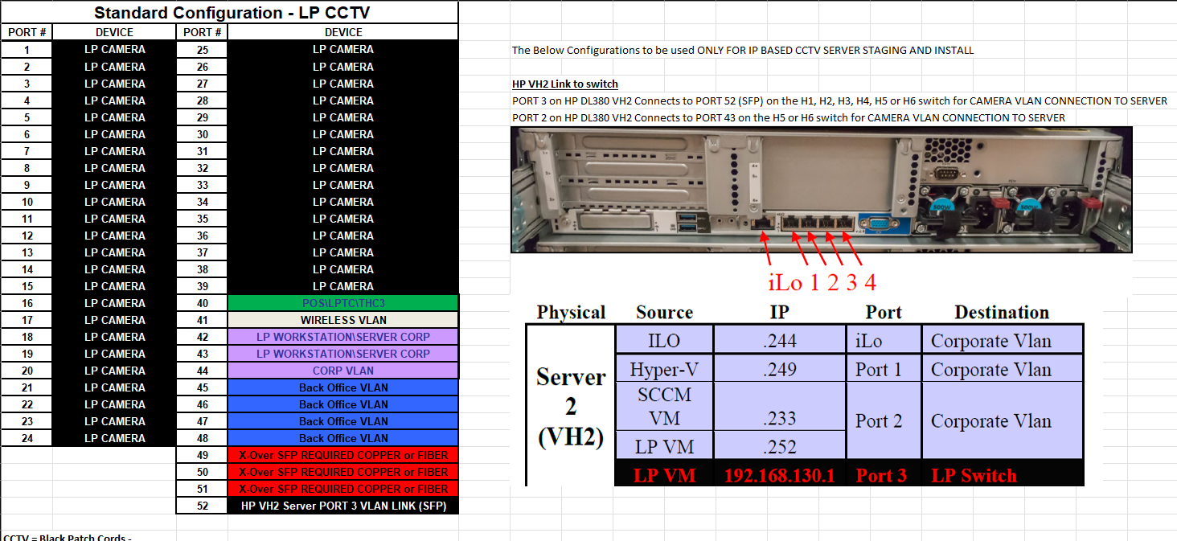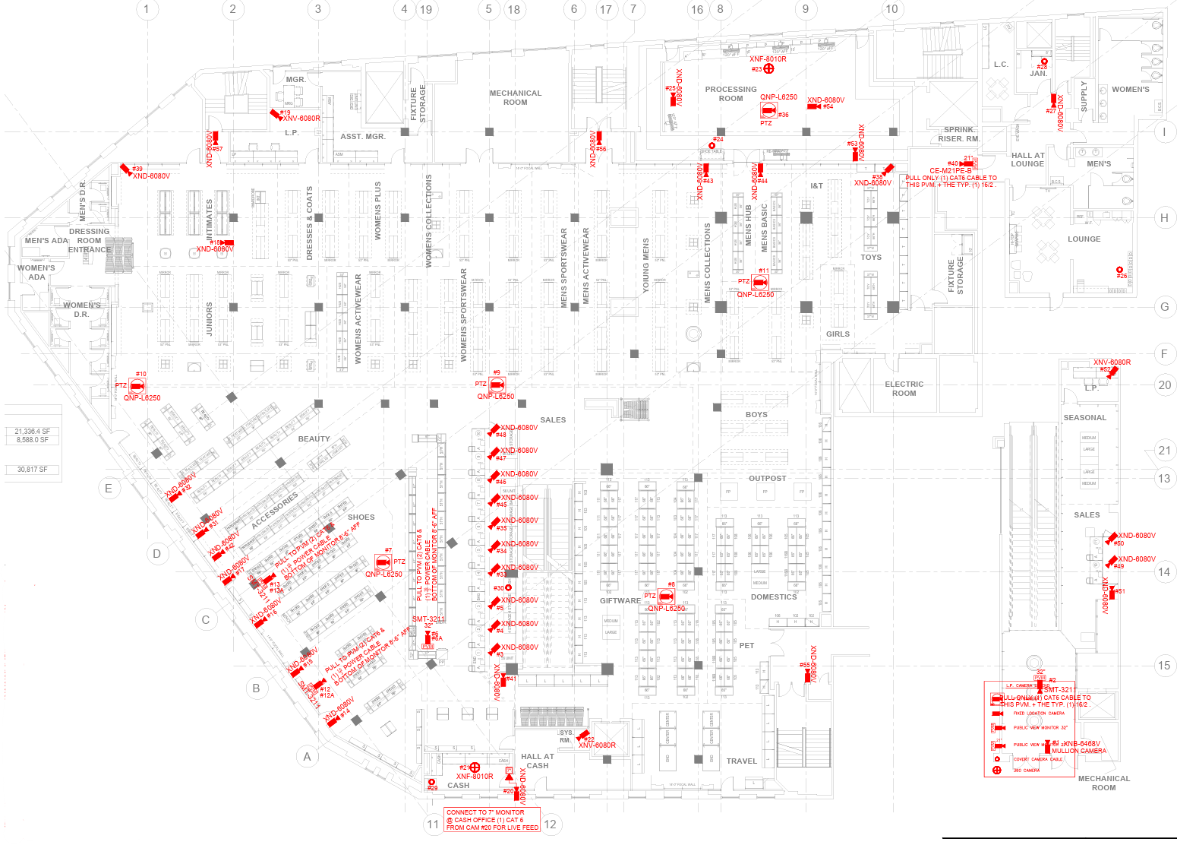

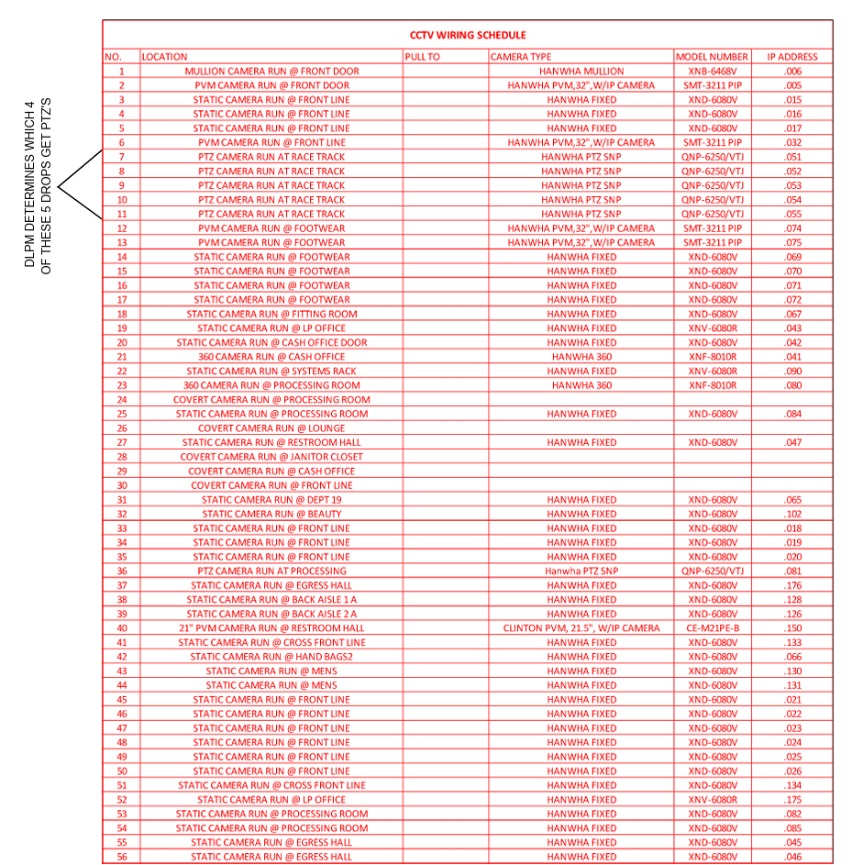
LP Command Center (Staffed 24hrs/day M-F)
888-444-4848
Option 1 (English)
Option 9 (Command Center)
Option 1 (New Releases)
Option 4 (LP CCTV)
TJX LP Projects Team
1. Project Engineers
1. Matt McNeal (978-675-6180)
2. David Benedek (438-368-3804)
2. Alex MacDowall (226-988-8575)
3. Joe Benson (860-949-0200)
4. Ron Doane (978-760-9497)

Additional Installation Notes:

During cleanup any addition cable or supplies (Cat6, 18/2 wire or termination supplies only) not utilized during install can be taken from site by technician or disposed of in approved disposal location

Qline PVMs Model SMT-3211PVM
Footwear PVMs Model SMT-3211PVM
Decoder Model SPD-150

Each of these PVMs require 2 data drops. One for the PVM and the second for the decoder.
The decoder is affixed to the back of the PVM via stick on Velcro strips and or zip ties.
There is also and HDMI cable that runs from the decoder into the PVM

There is also an HDMI cable that runs from the decoder into the PVM

