Juniper Retail Hardware Installation Guide

- Hardware Overview:

  - Juniper Router SSR130

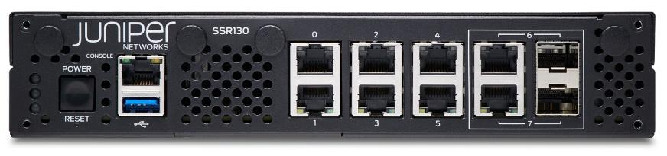

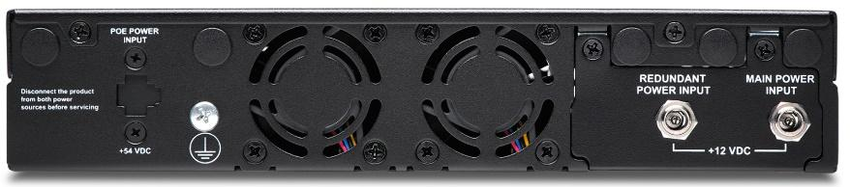

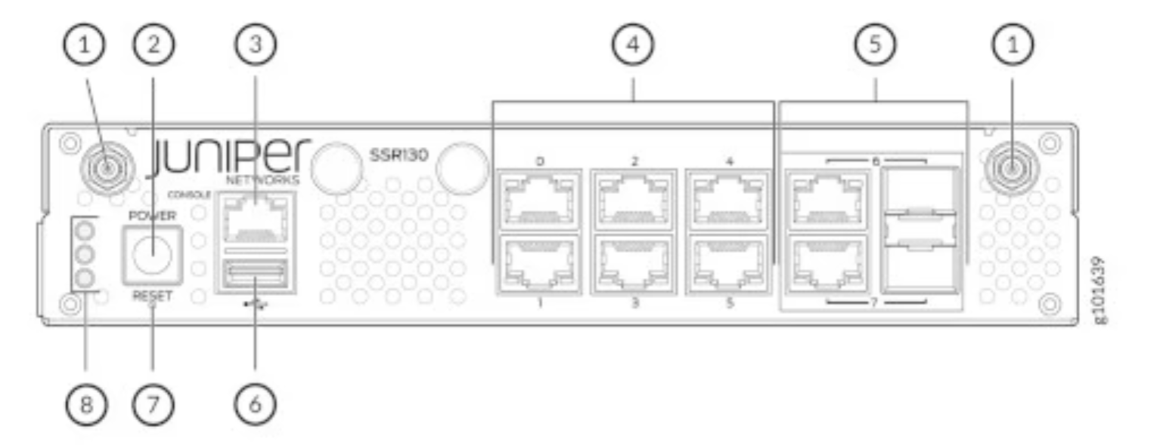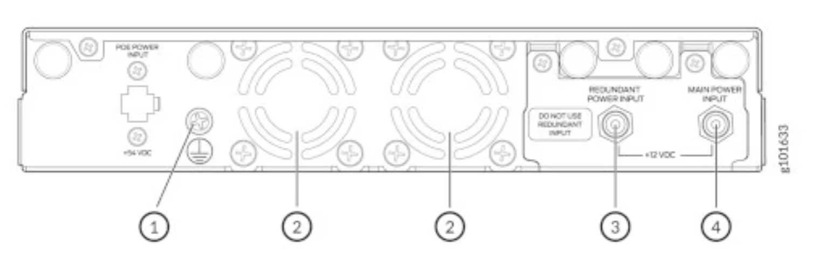

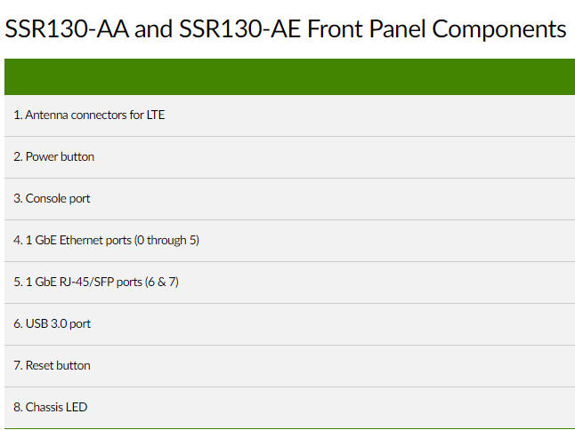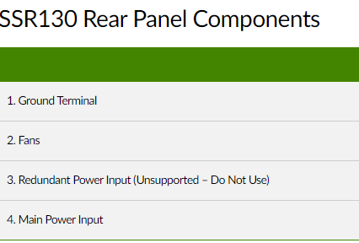

  - Juniper Switch EX4100-48MP

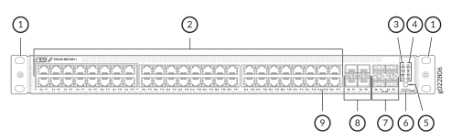
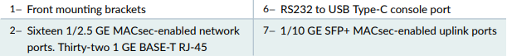
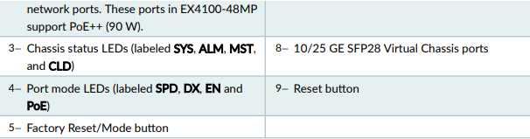

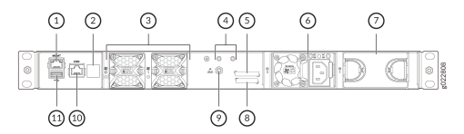
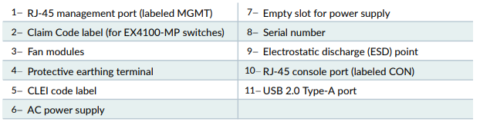

- High-Level Installation Steps:

Note:
- Call NOC Retail Deployment at 1-866-783-9557
- Steps in * must be completed under the guidance of NOC Retail Engineer

- Quick look at the network room and be prepared with a ladder if needed (~5mins)
- Unboxing the new hardware to ensure you have everything needed for the night Section 3 (~ 15 mins)
- Label all the cables connected to the existing Cisco router and switches Section 4 (~30 mins)
- *Unrack the existing Cisco router and switches (~15mins)
- *Rack the new Juniper Router, Switches, and Tripp-Lite PDU (~30mins)
- *Complete the initial WAN and LAN cable connection - Sections 6 and 7 (~15mins)
- *Power up the new Juniper router and switches by connecting them to Tripp-Lite Section 8 (~5 mins)
- *Complete the VCP connection Section 9 (~5 mins)
- *Connect layer 2 wired client connection Sections 10 and 11 (~30 mins)
- *Install, Power and connect new Cradlepoint W1850 Section 12 (~20 mins)
- *Re-label the cables connected to the new Juniper Router and Switches (~30 mins)
- Share the final installation pictures with NOC Retail Deployment
- Packed all the old equipment in the box

- Unboxing:

- Hardware:
  - SSR130(x1) + Rackmount kit
  - EX4100-48MP(x2) – Comes with a Rackmount
  - Triplite(x2)
  - Cradlepoint W1850 (x1)
- Cable:
  - Four Cat6 Ethernet Straight through cables - For connection between Router and Switches
  - Two optical Fiber Cables – Switch Virtual Connect
- SFP:
  - Two SFP-1G-T-C - For connection between Router and Switches
  - Four SFPP-10G-SR-C – Switch Virtual Connect

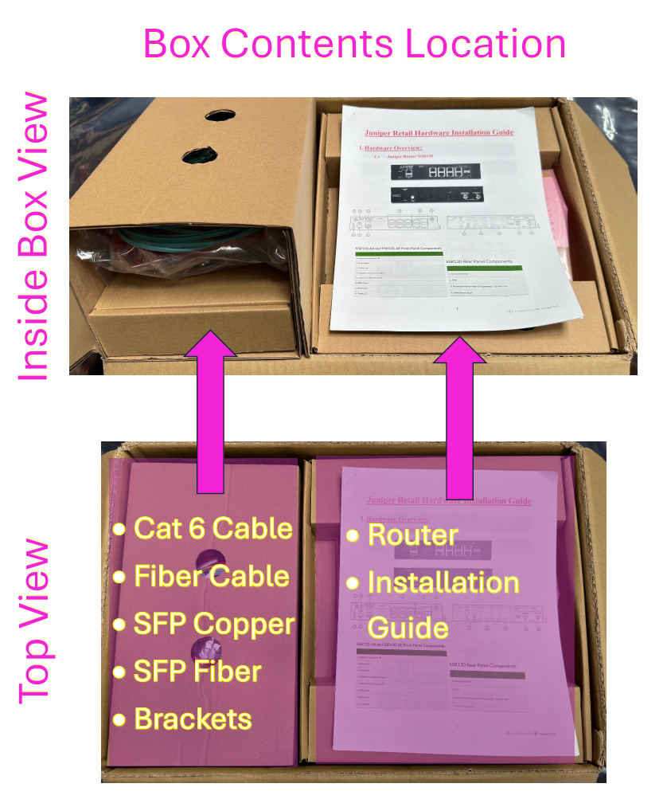
- Label:

Before starting the work, an onsite technician will be requested to label all the cables connected to the existing Cisco Router and Switches. These will be the temporary labels.

- WAN_Port#
  - Example: WAN_Port0
- Switch#_Port#
  - Example: Switch0_Port40
  - Example: S0_P40

- Juniper Hardware Claim code:

Note: Share the claim codes to the NOC Retail Engineer

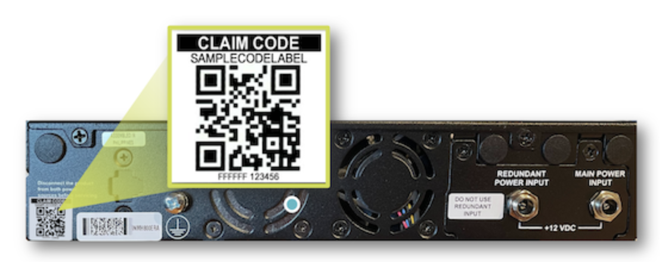
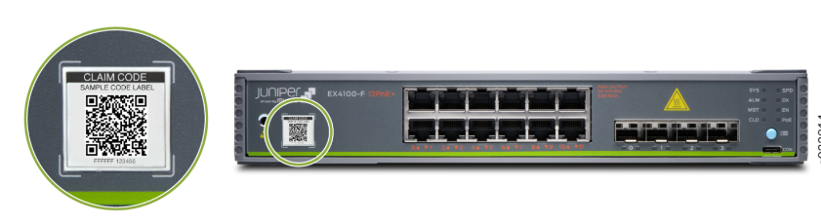

- ISP Connection to the Juniper Router

A-side | SFP A-side | Port A-side | Z-side | SFP Z-side | Port Z-side | Cable type
Juniper SSR130 | NA | 0 | ISP Modem (Primary) | NA | NA | Cat6 Straight
Juniper SSR130 | NA | 1 | ISP Modem (Secondary) | NA | NA | Cat6 Straight
Juniper SSR130 | NA | 2 | Cradlepoint | NA | LAN 1 | Cat6 Straight
Juniper SSR130 | NA | CONSOLE | Cradlepoint | NA | CONSOLE | Cat6 Rollover

Primary Broadband
Cradlepoint LAN 1

Cradlepoint Console

Secondary Broadband

- Connection between Juniper Router and Switches

A-side | SFP A-side | Port A-side | Z-side | SFP Z-side | Port Z-side | Cable type
Juniper SSR130 | NA | 4 | Juniper EX4100-48MP (Switch 0) | SFP-1G-T-C | Slot 2 Port 0 | Cat6 Straight
Juniper SSR130 | NA | 5 | Juniper EX4100-48MP (Switch 1) | SFP-1G-T-C | Slot 2 Port 0 | Cat6 Straight
Juniper SSR130 | NA | 6 | Juniper EX4100-48MP (Switch 0) | NA | MGMT | Cat6 Straight
Juniper SSR130 | NA | 7 | Juniper EX4100-48MP (Switch 1) | NA | MGMT | Cat6 Straight

Juniper EX4100-48MP (Switch 0)
Juniper EX4100-48MP (Switch 1)

Juniper SSR130
- PDU Connection

- Make sure to power up the new Juniper hardware in the below order:
  - Router – PDU A Port 8
  - Switch 0 – PDU A Port 6
  - Switch 1 – PDU B Port 4
- Note: NOC Retail will come later to this section to connect the below hardware:
- Cradlepoint – PDU B Port 8
- Modem 1 – PDU A Port 2
- Modem 2 – PDU B Port 1

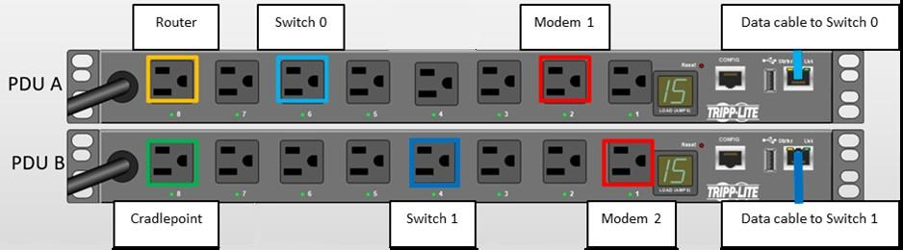

- Switches Virtual Chassis (VCP) Connection

A-side | SFP A-side | Port A-side | Z-side | SFP Z-side | Port Z-side | Cable type
Juniper EX4100-48MP  (Switch 0) | SFPP-10G-SR-C | Slot 1 Port 0 | Juniper EX4100-48MP (Switch 1) | SFPP-10G-SR-C | Slot 1 Port 0 | Optical fiber
Juniper EX4100-48MP  (Switch 0) | SFPP-10G-SR-C | Slot 1 Port 1 | Juniper EX4100-48MP (Switch 1) | SFPP-10G-SR-C | Slot 1 Port 1 | Optical fiber

Juniper EX4100-48MP (Switch 0)

Juniper EX4100-48MP (Switch 1)

- Layer 2 – Cisco Switch 1 to Juniper Switch 0

Cisco Switch 1 (C9300-48P) |  | Juniper Switch 0 (EX4100-48MP)
Port | Device | Port | Device | Notes
1 | Cash Drawer 1 | 0 | Cash Drawer 1
2 | Cash Drawer 2 | 1 | Cash Drawer 2
3 | Wireless AP – 04 | 2 | Wireless AP – 03 | Moved
4 | Wireless AP – 05 | 3 | Wireless AP – 04 | Moved
5 | Wireless AP - 23 | 4 | Wireless AP - 22 | Moved
6 | Burglar Alarm monitor | 5 | Burglar Alarm monitor
7 | Tyco ADT DVR | 6 | Tyco ADT DVR
8 | QuEST EMS | 7 | QuEST EMS
9 | Payment Kiosk #1 | 8 | Payment Kiosk #1
10 | Payment Kiosk #2 | 9 | Payment Kiosk #2
11 | BCM50 Phone System | 10 | BCM50 Phone System
12 | Mood Media - StoreMusic | 11 | Mood Media - StoreMusic
13 | Retail_Training | 12 | Training Station 6
14 | Printer 5 | 13 | Printer 5
15 | MAC Mini Content Server 1 | 14 | MAC Mini Content Server 1
16 | ShopperTrak | 15 | ShopperTrak
17 | ShopperTrak | 16 | ShopperTrak
18 | Cartier Coupler 1 | 17 | PDU A | New Hardware
19 | Cradlepoint | 18 | Cradlepoint
20 | IP BTS | 19
21 | Itunes Analytics (Pervacio) | 20 | Itunes Analytics (Pervacio)
22 | Training orange jack (live on EIT) | 21 | Training orange jack (live on EIT)
23 | Itunes Analytics (Pervacio) | 22 | Itunes Analytics (Pervacio)
24 | UMTS Repeater manager | 23 | UMTS Repeater manager
25 | Printer 1 (Color) | 24 | Printer 1 (Color)
26 | Printer 2 | 25 | Printer 2
27 | Printer 3 | 26 | Printer 3
28 | Printer 4 | 27 | Printer 4
29 | Brother Label Printer | 28 | Brother Label Printer
30 | BOH VoIP/Mgr Desk | 29 | BOH VoIP/Mgr Desk
31 | BOH VoIP/Mgr Desk | 30 | BOH VoIP/Mgr Desk
32 | BOH VoIP/Mgr Desk | 31 | BOH VoIP/Mgr Desk
33 | Cartier Coupler 2 | 32
34 | Convergent Media Player 1 | 33 | Convergent Media Player 1
35 | Convergent Media Player 2 | 34 | Convergent Media Player 2
36 | Convergent Media Player 3 | 35 | Convergent Media Player 3
37 | Convergent Media Player 4 | 36 | Convergent Media Player 4
38 | Convergent Media Player 5 | 37 | Convergent Media Player 5
39 | Convergent Media Player 6 | 38 | Convergent Media Player 6
40 | Convergent Media Player 7 | 39 | Convergent Media Player 7
41 | VoIP/POS system | 40 | VoIP/EIT system
42 | VoIP/POS system | 41 | VoIP/EIT system
43 | VoIP/POS system | 42 | VoIP/EIT system
44 | VoIP/POS system | 43 | VoIP/EIT system
45 | VoIP/POS system | 44 | VoIP/EIT system
46 | VoIP/POS system | 45 | VoIP/EIT system
47 | VoIP/POS system | 46 | VoIP/EIT system
48 | VoIP/POS system | 47 | VoIP/EIT system

- Layer 2 – Cisco Switch 2 to Juniper Switch 1

Switch 2 (C9300-48P) |  |  | Switch 1 (EX4100-48MP)
Port | Device | Port |  | Device | Notes
1 | Cash Drawer 3 | 0 |  | Cash Drawer 3
2 | Cash Drawer 4 | 1 |  | Cash Drawer 4
3 | Cash Drawer 5 | 2 |  | Cash Drawer 5
4 | MAC Mini Content Server 2 | 3 |  | MAC Mini Content Server 2
5 | Layer3 TV 1 | 4
6 | Layer3 TV_Convergent Touchscreen Media Player | 5 |  | Convergent Touchscreen Media Player
7 | Layer 3 TV_Convergent Media Player | 6 |  | Convergent Media Player 9
8 | Training Station 1 | 7 |  | Wireless AP - 01 | Moved
9 | Training Station 2 | 8 |  | Wireless AP - 02 | Moved
10 | Training Station 3 | 9 |  | Wireless AP - 05 | Moved
11 | Training Station 4 | 10 |  | Wireless AP - 21 | Moved
12 | Training Station 5 | 11 |  | Wireless AP - 23 | Moved
13 | Training Station 6 | 12 |  | Future AP ports
14 | Training Station 7 | 13 |  | Future AP ports
15 | EPIK | 14 |  | EPIK | New Hardware
16 | Device Wizard | 15 |  | Device Wizard
17 | Device Wizard | 16 |  | Device Wizard
18 | Additional Device | 17 |  | PDU B | New Hardware
19 | Printer 6 | 18
20 | Wireless AP – 01 | 19 |  | Training Station 1 | Moved
21 | Wireless AP – 02 | 20 |  | Training Station 2 | Moved
22 | Wireless AP – 03 | 21 |  | Training Station 3 | Moved
23 | Wireless AP – 21 | 22 |  | Training Station 4 | Moved
24 | Wireless AP – 22 | 23 |  | Training Station 5 | Moved
25 | Cash Drawer 6 | 24
26 | Cash Drawer 7 | 25
27 | Cash Drawer 8 | 26
28 | Cash Drawer 9 | 27
29 | Cash Drawer 10 | 28
30 | Cash Drawer 11 | 29
31 | Backroom Scala Media Player | 30 |  | Backroom Scala Media Player
32 | Aruba Controller | 31
33 | Convergent Media Player 8 | 32 |  | Convergent Media Player 8
34 | Entouch - HVAC | 33 |  | Entouch - HVAC
35 | RetailNext | 34 |  | RetailNext
36 | InVue | 35 |  | InVue
37 |  | 36
38 |  | 37
39 | PICO Cell | 38 |  | PICO Cell
40 | PICO Cell | 39 |  | PICO Cell
41 | POC | 40 |  | POC
42 | POC | 41 |  | POC
43 | POC | 42 |  | POC
44 | POC | 43 |  | POC
45 | POC | 44 |  | POC
46 | POC | 45 |  | POC
47 | POC | 46 |  | POC
48 | POC | 47 |  | POC

- Cradlepoint W1850 Connection

Note: Technician will reuse the existing cable connection for new Cradlepoint installation

- Connect Cradlepoint LAN 1 to SSR Router Port 2
- Connect Cradlepoint LAN 2 to EX4100 Switch 0 Port 18
- Connect Cradlepoint CONSOLE to SSR CONSOLE

