New Store Installation Guide
Revised 02/27/2025.

Table of Contents
Contacts 4
Overview 5
Site Preparations – GC Requirements 5
Phase 1: Cable Rough-In and Network Rack Installation 5
Phase 2: Equipment Installation 5
Technician Requirements 6
Phase 1: Overview 7
Wachter/GC Coordination Meeting 7
Equipment Inventory 7
Network Rack Installation 7
Network Equipment Install 7
Cabling Standards 10
General 10
Labeling Scheme 10
Cabling Quantities 11
Cashwrap 11
Access Points 12
Shopper Trak 12
Fitting Room Phone 13
Managers Office 13
Enterprise Desk 14
Speaker Cabling and Installation 14
Cabling: See plans for speaker quantities and locations. 14
Installation 15
AMP Wiring Diagrams 16
Phase 2: Overview 17
Step 1: Equipment Inventory 17
Step 2: Network Equipment Installation 17
Switch Port Diagram 18
48 Port Switch 18
MX85 Router 19
MG51E (Cradle point) 20
MG51E (Cradle point) status code light indicators below: 21
Stingray Music Player Installation 22
Step 3: POS/Register Installation 22
Step 3: Manager Desk Equipment Install 26
Step 4: Shopper Trak Installation 29
Step 5: Access Point Installation 30
Step 6: Phone Installation 31
Phone for Cashwrap Drawer 32
Equipment Validation and Close Out 32

***MUST WEAR ALL PPE AND PERFORM JOB HAZARD ANALYSIS BEFORE BEGINNING ANY WORK***

Contacts
  - Wachter Support Contacts

- Email for all Wachter contacts: jcrewsupport@wachter.com
- Christian Wood – Wachter Project Coordinator
  - Phone:
- Grayson Hunter – Wachter Project Manager
  - Phone:
- Hayden Miller – Wachter Project Manager 2
  - Phone:
- Leigh Ann Heaton – Wachter Team Lead
  - Phone: 479-879-1830

J.Crew IT Contacts
- PRIMARY CONTACTS:
- Joey Palumbo– J.Crew IT Support
  - Phone: 347-814-2992
  - Email: joseph.palumbo@JCrew.com
- Joel Ralph – J.Crew IT Assistant Manager
  - Phone: 646-770-6790
  - Email: joel.ralph@Jcrew.com
- SECONDARY CONTACT:
- Sebastian Bonilla – J.Crew IT Support
  - Phone: 347-573-1891
  - Email: sebastian.bonilla@jcrew.com
Other Contacts
- On-Site Media for Bose speaker support
  - Joe Kidwell: 435-214-4497 Ext. 177
- Shopper Trak Support
  - Phone: 312-529-5301

Overview
This document provides guidance on the pre-deployment, deployment, and installation of retail technology at J.Crew, Madewell, and J.Crew Factory Retail Stores. If you have any questions or encounter issues, please contact us at JCrewSupport@Wachter.com.

Site Preparations – GC Requirements
This section outlines the prerequisites that the General Contractor (GC) must fulfill before the arrival of Wachter technicians on-site. These preparations are categorized into two phases: one for the cable rough-in and network rack installation (Phase 1) and the other for the equipment installation phase (Phase 2).

Phase 1: Cable Rough-In and Network Rack Installation
Before initiating Phase 1 Rough-in, ensure the following preparations have been accomplished:
- Installation of Plywood Backboard: A plywood backboard must be securely installed at the designated network rack location, ensuring that the bottom of the backboard allows for our rack to be no less than 8 feet Above Finished Floor (AFF). Typically, the network rack is situated at the top right of the backboard. Dimensions below:
CHATSWORTH 11791-725 SWING GATE 19IN
WX38.5IN HX25IN D BK

- Permanent Power: Power should be made permanent and installed within a 3-foot radius of the future rack location. Please ensure electrical team has power onsite.
- Conduit Stub-Up: The installation of conduit stub-up is necessary. It should be placed at the top of the backboard and in the middle of the future rack location, with the specifications as follows:
  - 2-inch stub-up for 35 cables or less.
  - 2.5-inch stub-up for 60 cables or less.
- Wall Data Drops: Cutouts and boxes for all wall data drops should be in place.
- Conduit Work: Conduit work for both Cashwrap and Shopper Trak installations should be completed.
- Speaker Mounts (if applicable): Ensure the installation of speaker mounts has been carried out.

Phase 2: Equipment Installation
- Furniture for Cash Wrap: The cash wrap area should be equipped with the requisite furniture.
- Manager's Office Desk: The manager's office desk should be in place.
- Permanent Power: “Permanent” power should be installed for the cash wrap furniture and managers desk.

Technician Requirements
This section outlines the essential requirements and protocols for Data technicians:
- Prompt Arrival: It is mandatory for the technician to initiate contact with the Wachter Project Manager upon arrival. In the event of expected delays, the technician must contact the Project Manager prior to the scheduled arrival time.
- Safety Responsibility: The technician bears the responsibility of promptly reporting any safety concerns encountered during the assignment. All safety issues must be communicated immediately to both the General Contractor (GC) and the Wachter Project Manager.
- Inventory and Documentation: Prior to commencing any work, the technician is obligated to perform a comprehensive inventory of equipment and capture "BEFORE" photographs. Both the inventory list and "BEFORE" photos must be submitted to the Wachter Project Manager via email or Trust before commencing the assigned tasks.
>>>Our group distribution email is JCrewSupport@Wachter.com <<<
- Quality: All cables are required to maintain a clean and organized appearance in compliance with Wachter standards. This entails combing, dressing, and bundling the cables using Velcro for a neat and professional presentation.
- Daily Reporting: Daily work orders, inventory lists, and any deliverables such as photographs and test results must be submitted to JCrewSupport@Wachter.com.
>>>Please be sure to send email with pictures and description of work performed on said work order before leaving and call PM to discuss<<<
- Checking Out: Upon completion of work, it is imperative to contact the Project Manager or Dispatcher to initiate the check-out process. A detailed summary of the work completed should be readily available.
Failure to complete the check-out process with the Wachter Project Manager or to submit daily deliverables before departing may result in a recorded incident known as a "WALK-OFF."

Phase 1: Overview
The primary objective of this phase is to execute the installation of data and speaker cabling, network rack, patch panel, UPS, amplifier, and speakers. The subsequent tasks must be undertaken in the specified sequence as outlined in this Statement of Work (SOW). Any necessary deviations from this sequence should be promptly communicated to the Wachter Project Manager.

Wachter/GC Coordination Meeting
Wachter/GC Coordination Meeting Upon arrival, the technician will conduct a collaborative meeting with the General Contractor (GC). This meeting serves to inspect the store, identify the backboard location, conduits, equipment placement, etc.

Equipment Inventory
The technician will locate and inventory the following equipment:
- Speakers (referring to the provided print for the precise quantity)
- Amplifier (AMP)
Should any discrepancies arise where equipment is unaccounted for, immediate contact with the Wachter Project Manager is imperative.

Network Rack Installation
The assembly and mounting of the network rack will be performed at the upper right section of the backboard, ensuring that the bottom edge is positioned no lower than 8 feet above finished floor (AFF). In cases where this configuration is not feasible, prompt communication with the Wachter Project Manager is necessary.

Network Equipment Install
Arrange the equipment precisely in accordance with the provided diagram, following this sequence:
- Patch Panel at the topmost position.
- Maintain a vacant space of 14 rack units (RU).
- Place the AMP.
- Position the UPS (Battery Backup).

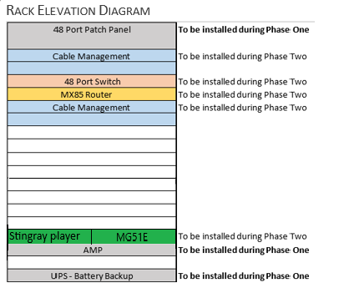

Finished Rack Example After Phase One
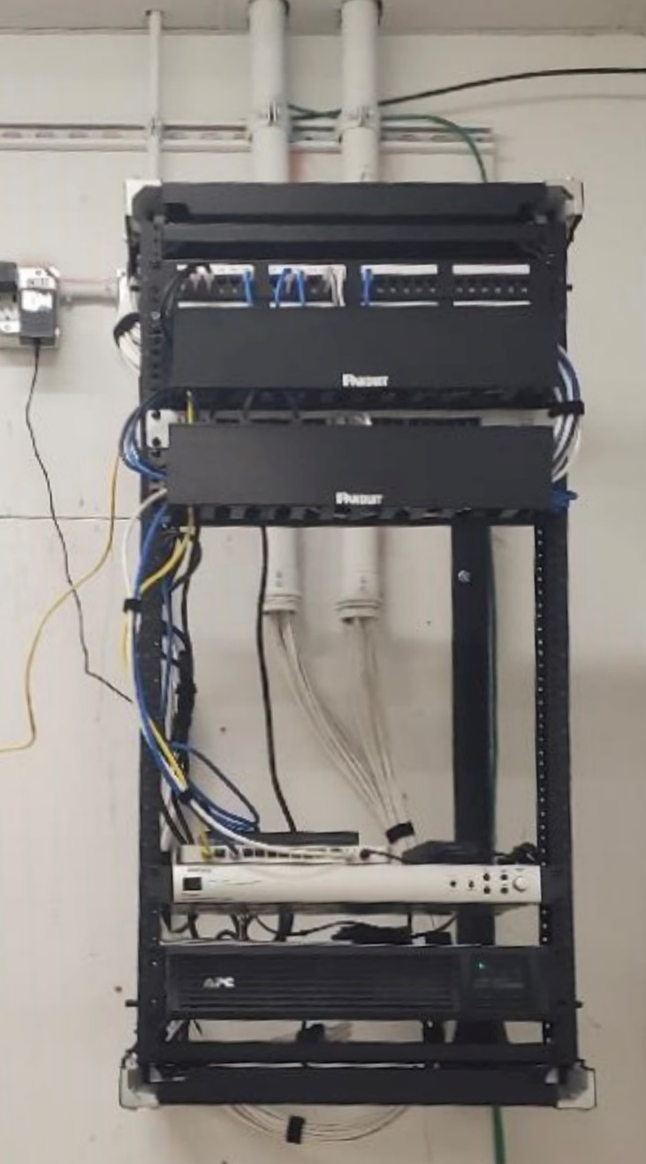

Cabling Standards

General
All cabling will be Cat6 Plenum
All cabling will be properly supported in J-Hooks, installed on structural steel, or wall studs.
Cabling will be terminated to jacks and patch panels utilizing TSB 568B standard.
All cabling will need to be tested, and test results submitted with your deliverables. Picture of tester will work.
If walls have not been painted, all wall drops will be terminated and wrapped with a bag then pushed into the wall.
Example
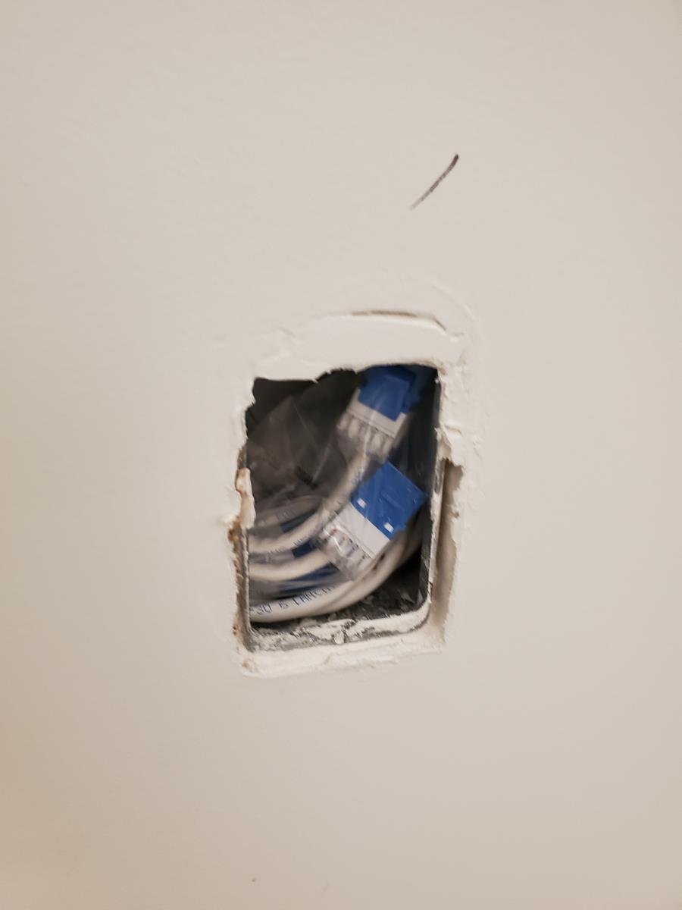

Labeling Scheme
Each cable and its corresponding faceplate or surface mount box will feature a unique identifier in the form of a number/letter combination.
- Data cables will be marked as D1, D2, D3, and so on.
- Voice cables will carry labels like V1, V2, V3, and so forth.
- Access points will be identified as AP1, AP2, and so on.
- Shopper Track cables will be denoted as ST.
For example, a 4-port faceplate (or Surface Mount Box) will be tagged as 1D, 2D, 3D, and 4D, while a 1-port faceplate designated for phones will be labeled as 1V.
The patch panel will also be labeled to correspond with the faceplate or Surface Mount Box labels. Data drops will occupy ports 1-24, and voice drops will be on ports 25-48.

Example of labeled patch panel
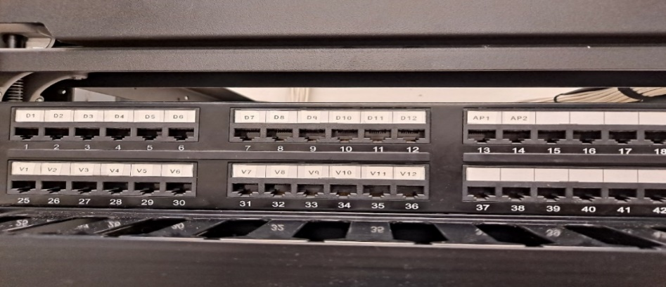

Cabling Quantities
Refer to marked layout provided to you by Wachter PM. If GC has different set of plans, let Wachter PM know immediately.

Cashwrap
- 1 Dual drop per each register
  - 1 Data and 1 voice
All cables will need to run through conduit that is provided by the GC. Coil the cable with 5’ of slack, label, and tape bundle together.
Example
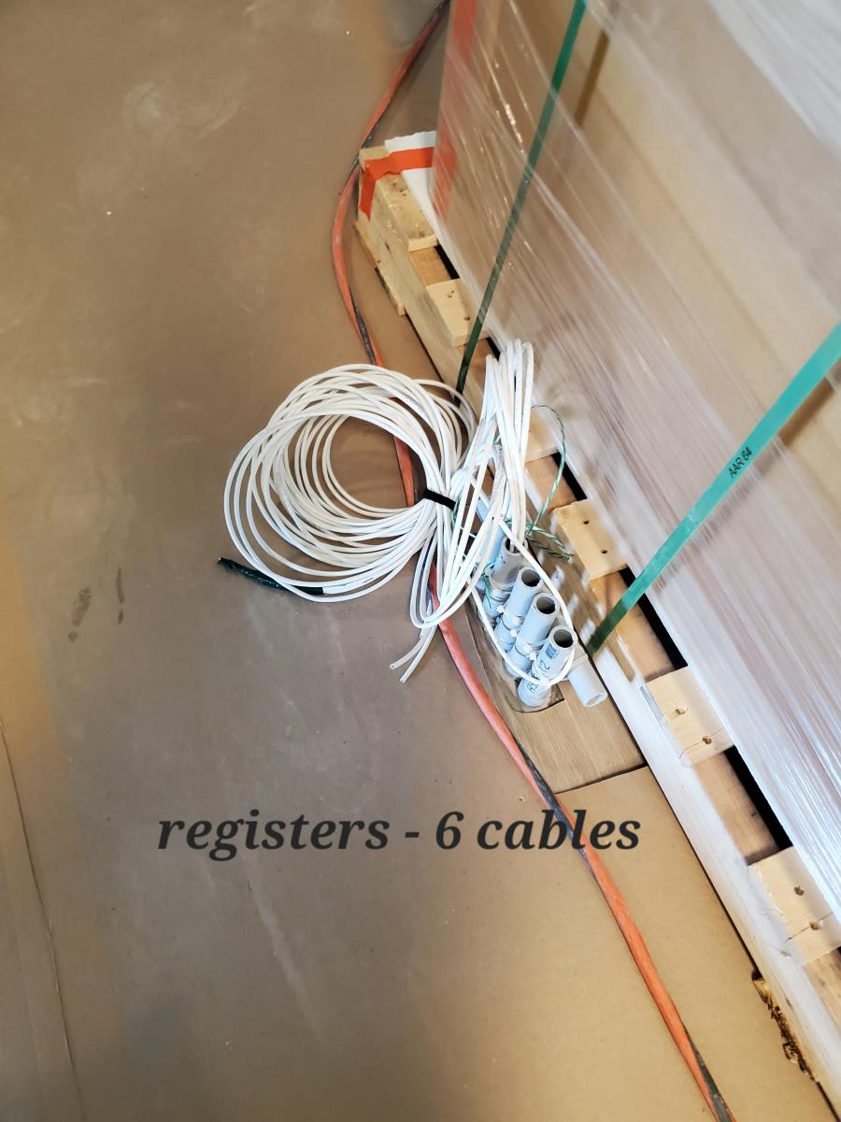

Access Points
- 1 Single data drop for each AP terminated to a surface mount box.
Make sure all cables are hidden and coil the cables with 5’ of slack.
Example
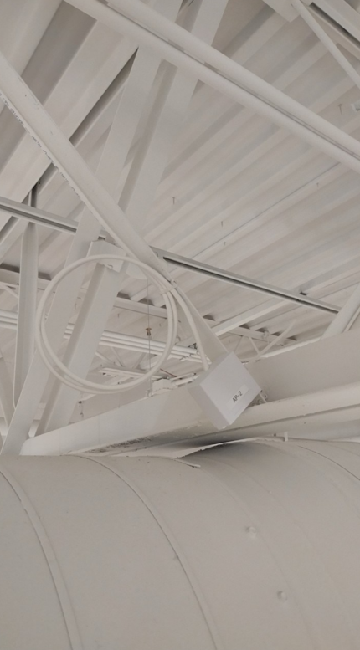

Shopper Trak
- 2 data drops for Shopper terminated to a surface mount box.
- Please leave at least (6-8) Feet of slack on the device end in case this is needed to shift over anywhere.
- One Drop will be used as a spare if needed for the MG51e Cradle Point
If the ceiling type is open, a conduit and box will be installed by the electricians. If this is not completed by the time you arrive, let the Wachter PM know immediately.
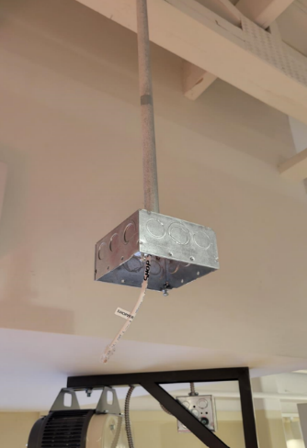

Fitting Room Phone
- 1 Single voice drop for phone.
- 48” AFF
Disregard if there is no fitting room on floorplan

Example:
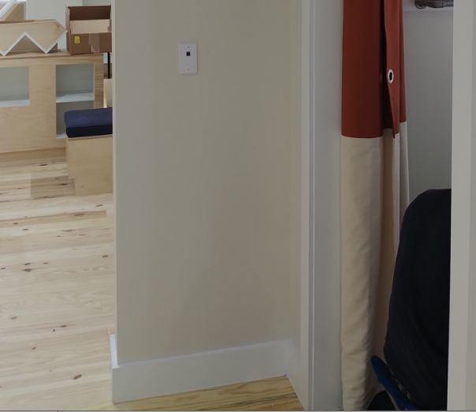

Managers Office
This desk will not be in place during phase one, but the electrician should have cutouts and boxes ready for our drops.
- 10 Total cables
  - 2 Quad drops
    - Below desk, one left and one right
    - Each drop will consist of 2 data and 2 voice
  - 1 Dual drop
    - Middle center, above desk
    - 1 Data and 1 voice

Example (manager’s office during rough-in)
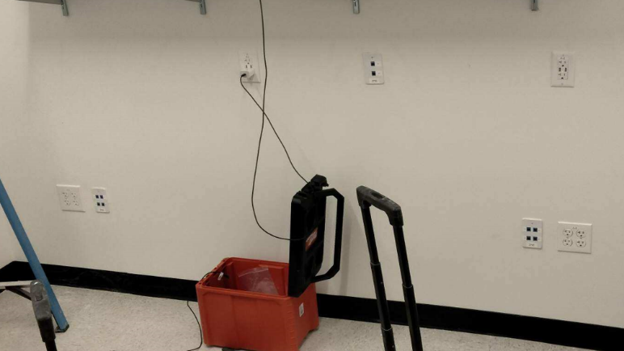

Enterprise Desk
This desk will not be in place during phase one, but the location should have a cutout and box for the drops.
- 4 data drops will be needed for all sites. This may also be referred to as the ES Desk.

Speaker Cabling and Installation

Cabling: See plans for speaker quantities and locations.
18/2 wire will need to be daisy chained from speaker to speaker, with one home run back to the AMP.
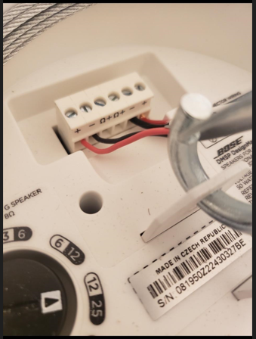

Installation
Open Ceiling – GC will install a mounting structure (usually a speaker pendant mount).
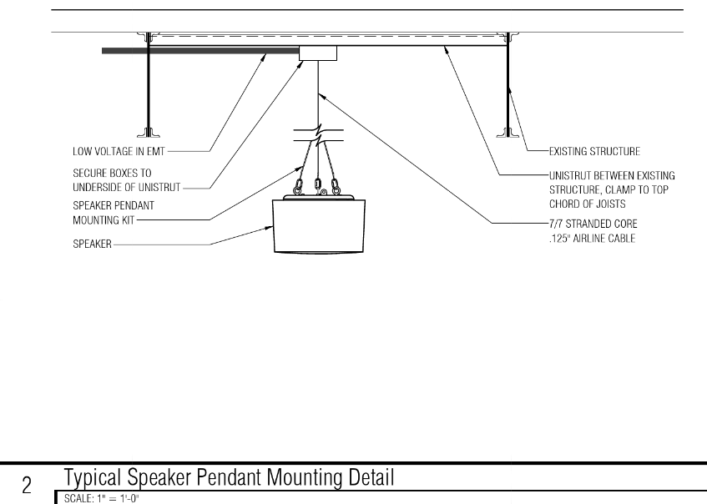

Hard Lid Ceiling or Drop Tile Ceiling – GC will usually provide cutouts, but if not, the technician will be required to make the cut out using the template provided in the speaker boxes.
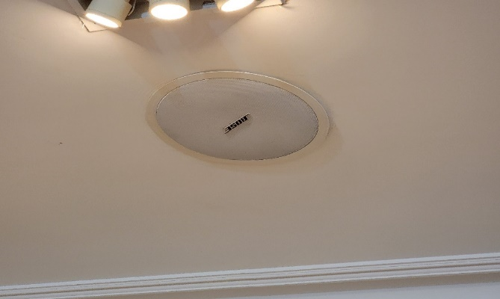

AMP Wiring Diagrams
- Connect the home run speaker wire to the TOP output channel, ensuring proper connection of positive and negative wires.
- Adjust the trim dial to a setting of 7.
- Activate switches 1, 3, and 5 among the top 6 "dip" switches by setting them to the ON position.
- MAKE SURE FRONT OF AMP IS TURNED ON. SET MASTER VOLUME TO 7 (Front of AMP).

Diagram of AMP configuration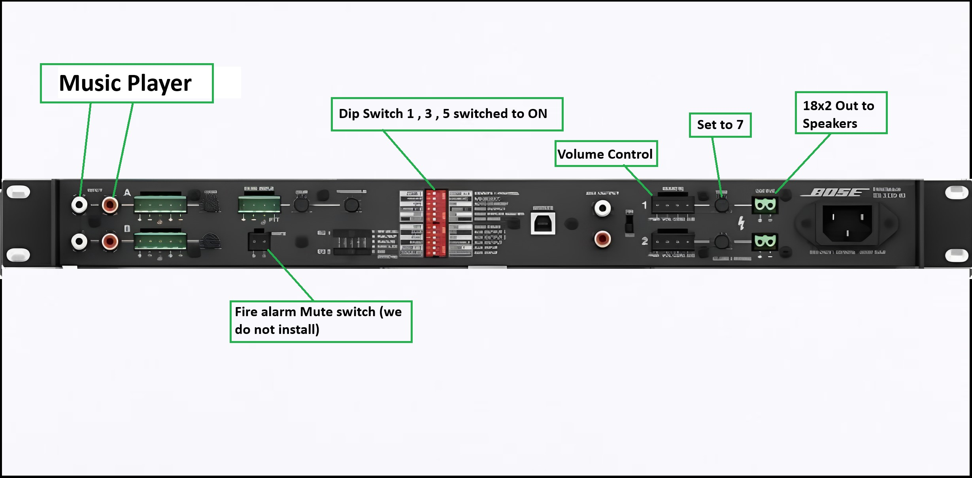
Phase 1 Check-off:
- Photos of rack installed
- Photos of patch panel terminated and labeled
- Cable test results
- Photos of AMP connections, testing
- Photos of AP SMBs labeled
- Photo of ShopperTrak SMB labeled

Phase 2: Overview
The purpose of this phase is to finalize the outstanding tasks, which usually involve cable termination at the Cashwrap, installation of all remaining network equipment, faceplates, POS stations, managers' office equipment, Shopper Trak devices, access points, printers, and phones.

Step 1: Equipment Inventory
The initial and crucial task for phase two is to conduct a comprehensive equipment inventory. Unbox each piece of equipment and visually inspect it for any signs of damage or scratches. If any issues are detected, promptly inform the Wachter Project Manager.
Complete the inventory sheet provided by the Wachter Project Manager and send it via email to jcrewsupport@wachter.com. Once this step is finalized, contact the Wachter Project Manager to report if any items are missing and to seek approval to proceed to the next phase.

Step 2: Network Equipment Installation
After completing the inventory process, your primary focus will be the installation of the remaining network equipment. It is essential to confirm with J.Crew IT that all network components are operational and online before proceeding.

Key Notes:
Consult the rack elevation and switch port diagram for guidance.
Connect all cables, adhering to the designated color scheme for clarity.
Ensure that all equipment is properly plugged into the Uninterruptible Power Supply (UPS) for reliable power.

Switch Port Diagram
Switchport | Description | Patch Cable Color
1 | Port 5 on MX85 Router | Blue
2 | HP Server (Reg 99) | Blue
3 | Printer | Blue
4-10 | Registers | Black
11-15 | Wireless APs | Gray
16 | Data | Blue
17 | Lightstat | Blue
18 | Shopper Trak | Blue
19 | Music Player | Blue
20 | Security Camera | Blue
21 | Associate Kiosk | Blue
22 | Dell Managers PC | Blue
23 | Guest Jack - Do not use | Blue
24 | Guest Jack - Do not use | Blue
25-32 | VOIP Phones | White
33-38 | Price Checkers | Blue
39-48 | Spare Data Ports | Blue

48 Port Switch
Install the 48-port switch in the position indicated on the rack elevation guide (pic below):

**INSERT MS130 SWITCH PORT DIAGRAM IN DOCUMENTATION REFRESH FOLDER**

MX85 Router
Install the MX85 in the position indicated on the rack elevation guide.

**INSERT MX85 DIAGRAM IN DOCUMENTATION REFRESH FOLDER**
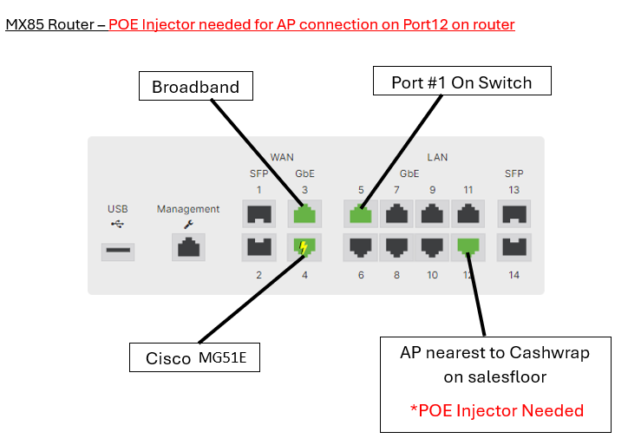

MG51E (Cradle point)
When locating the correct device, this is what the Cisco Meraki MG51E will look like:

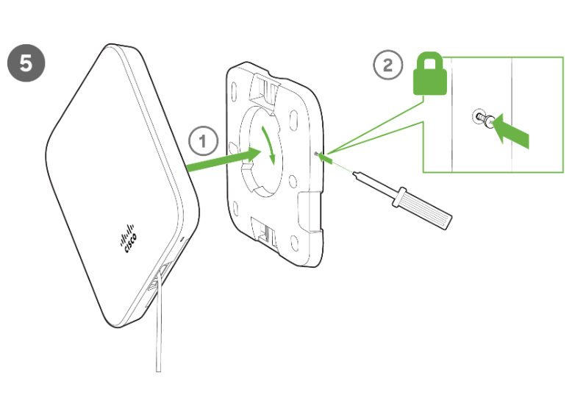

MG51E (Cradle point) status code light indicators below:
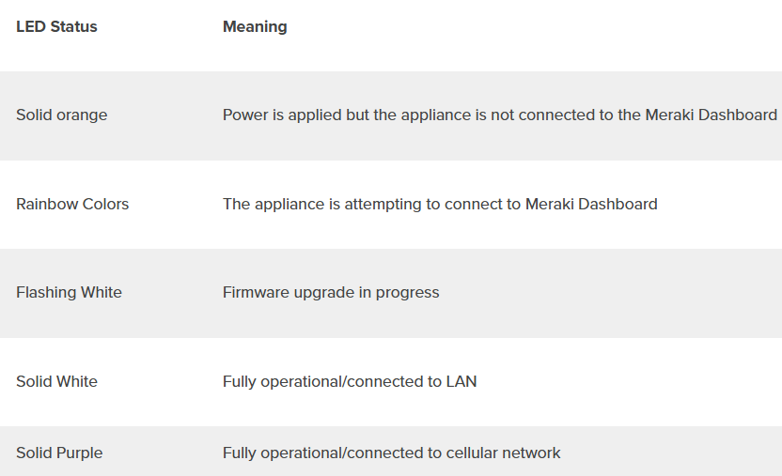

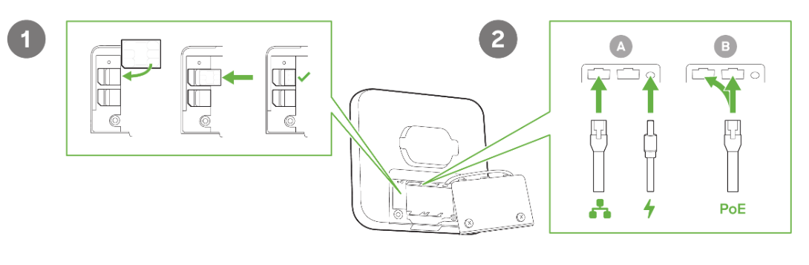

Stingray Music Player Installation
- The red and white AV cables are used to connect the music player to the amp as shown below.
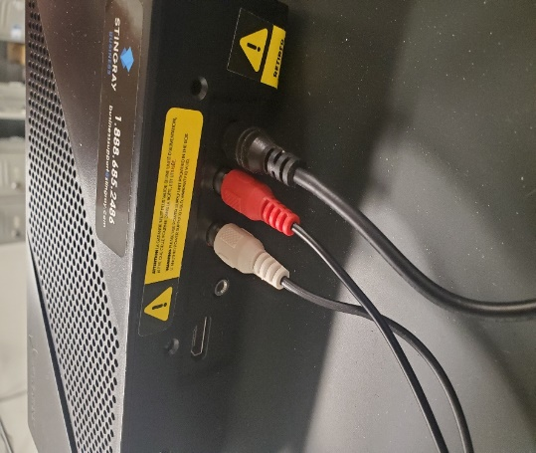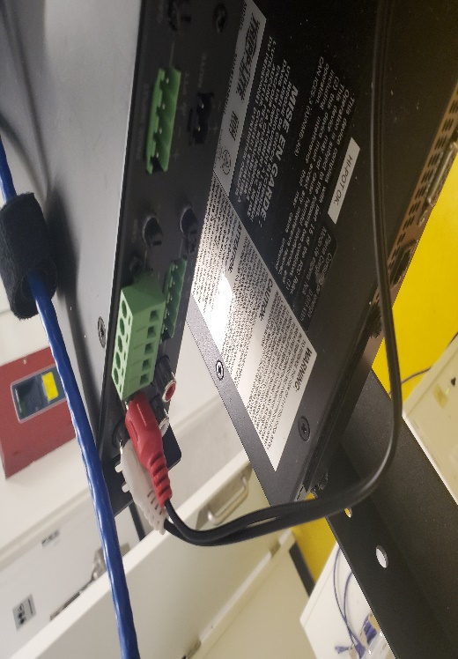
Figure 1: STINGRAY CONNECTION Figure 2: AMP CONNECTION
- If music is playing through the speakers, it confirms the proper functionality of the device.

Step 3: POS/Register Installation
- If a 4 square box has not been provided by the General Contractor (GC), the previously routed cables must be terminated to a surface mount box. In cases where there is no 4 square boxes, terminate the cables and install faceplates as necessary.
- Please ensure that all registers are in the CORRECT order. Once registers are in place, we can turn on the devices and, in the bottom left of the screen it will display the Register number.
- The POS HUBs should be installed at the rear of the cash wrap. It's important to place the hubs in their designated bay, keeping them separate from the Sensormatic equipment, as shown in the image labeled "Back of Register Setup."
- Ensure that all cabling is neatly organized and coiled using Velcro for a tidy appearance.
- Following the installation of the HUBs, proceed with the installation of the remaining POS stations. Refer to the setup images provided.
- Wachter does not install the Sensormatic equipment and it is out of our SOW.
Each POS station should include the following components:
HP RP1 Elite 3000 POS Terminal (connected to the POS HUB)
- HP Touch Screen (Monitor & counter top base)
- HP ElitePOS Serial USB Thermal Printer (for receipt printing) – LEAVE POWERED ON!
- HP ElitePOS 2D Barcode Scanner – Ensure there is slack on this connection to the hub.
- MX925 PCI 3.X SC (Pin Pad) and HP POS Keyboard
- HP Heavy Duty Cash Drawer – Ensure there is slack on this connection to the hub.

Back of Register Setup
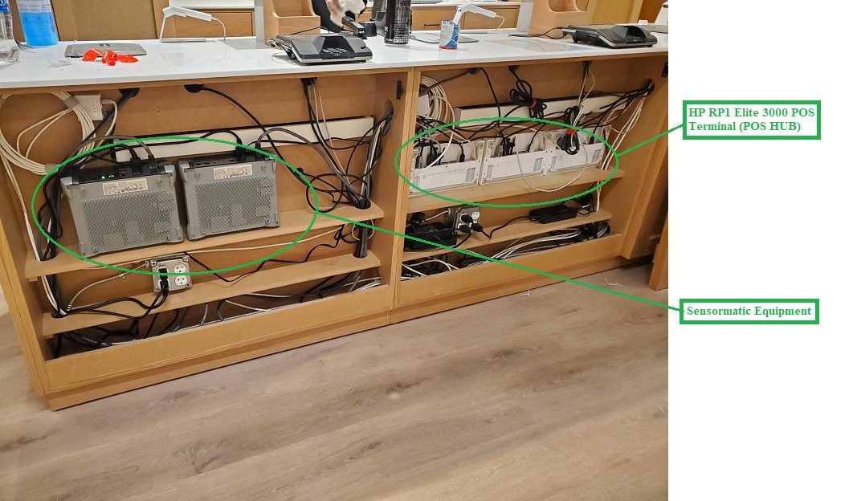
- Back of register setup, keep cables clean but not wrap/tape/zip so there is no ability to shift devices left/right due to cable length being limited. Try to leave some slack for device movement/shifting.

There will be certain sites that require a “hybrid-approach” to the register layout with HP registers as well as iPad registers.

All registers will have credit card readers with them. HP registers will continue to have the card reader that has a larger screen and lays more flat on the countertop.
iPad registers will have a handheld credit card reader that will sit/charge on a base that looks similar to what the iPad Register sits on.
See photo below of iPad register hardware and cash wrap layout. (Note most Factory builds will be 1HP/2iPad & Retail & Madewell counts will be based on store design device request)

HUB Cashwrap examples (1 Hp and 2 iPad Registers)

Example RETAIL cash wrap:
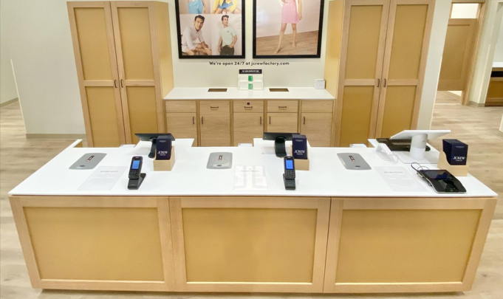

Example MADEWELL cash wrap:
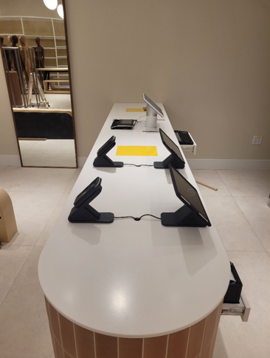

**INSERT PHOTO OF VASWANI BUILD CASHWRAP**

Example FACTORY cash wrap:

PRICE CHECKER INSTALLATION TBD> Please get with wachter PM. These will begin to be utilized starting with store 4018.
- These devices will be sent by apogee with the ipads & iphones.
- iPad being used will already be in wall mount fixture.

HUB Connections
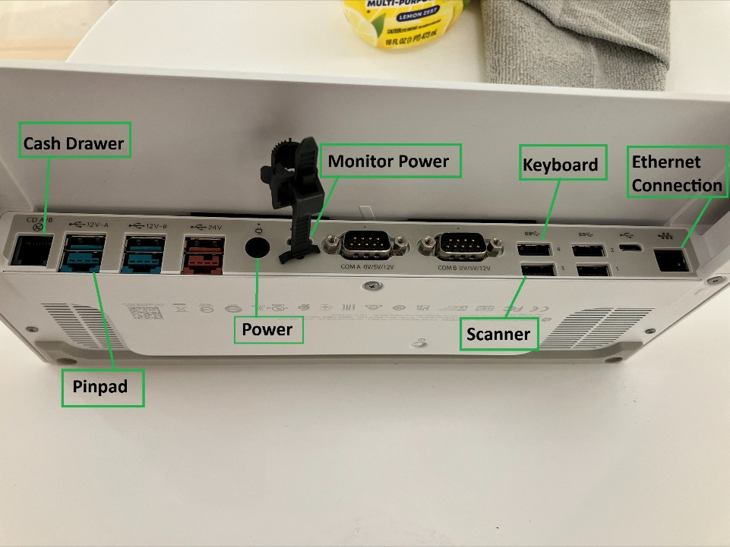
**INSERT NEW PHOTO OF HUB CONNECTIONS IN DOCUMENTATION REFRESH FOLDER**

Step 3: Manager Desk Equipment Install
The manager's desk will be equipped with the following components:
- Dell OptiPlex 3280 All-in-One XCTO (manager's computer)
- HP Office Printer
- HP Computer and an Acer or Dell monitor (referred to as "POS Server" or "POS 99") – DO NOT LEAVE SITE IF THIS IS NOT CONNECTED AND POWERED ON. Leave the Monitor on.

*Obtain office printer PIN # for Jcrew Retail Tech team. Press button on right side of printer to drop down ink door, sticker located on inside panel of the right side.
***ONCE PIN IS LOCATED: Please text Joel/Joey at their contacts (Table of Contents)***
>>Text can say: Store XXXX Printer PIN XXXXXXXXX or can send over clear photo of sticker with pin and site store number.

Example of pin location below:
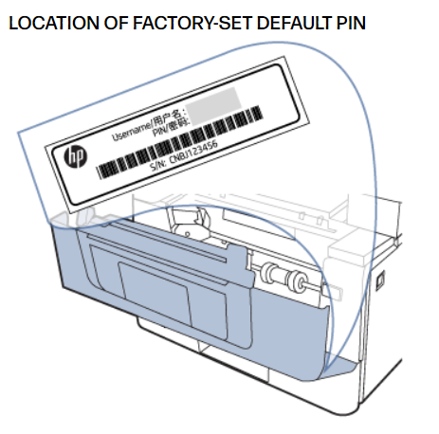
****Please ensure that all cables, both above and below the counter, are neatly organized to the best of your ability.

Please note that the installation of the wall-mounted monitor is not in our scope of work.

Example
**INSERT PHOTO OF MANAGERS DESK IN DOCUMENTATION REFRESH FOLDER**
Please also note that for all office devices: power, data and voice cabling should be plugged in UNDER the manager’s desk counter. No office devices should use outlets on top of the counter.

The Data outlet above the counter are to be labeled “Guest 1” and “Guest 2” and should be fully ran & patched into the necessary network switch ports. These ports are used by teams internally within JCrew for equipment inventory throughout the year.

Step 4: Shopper Trak Installation
The Shopper Trak Orbit should be installed with its two black cameras aligned parallel to the entrance door. Small LED Lights should be facing towards the exterior entrance doors if facing the correct direction.
In stores with open ceilings, a quad box will be suspended from the ceiling using ½” conduit, located near the door, with the necessary CAT6 cabling already in place from Phase 1.
For stores with closed/drop ceilings, the Orbit mount can be directly attached to the ceiling or mounted to the grid in the case of drop tile ceilings.
After mounting and connecting the device to the network, make sure the lens caps are removed, and contact ShopperTrak support at 312-529-5301 for calibration assistance.

Shopper Trak – Open Ceiling
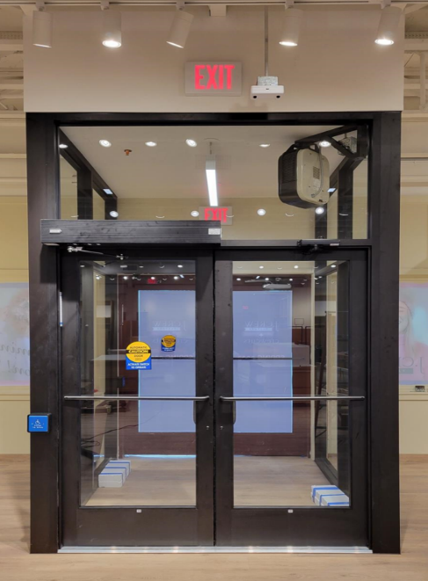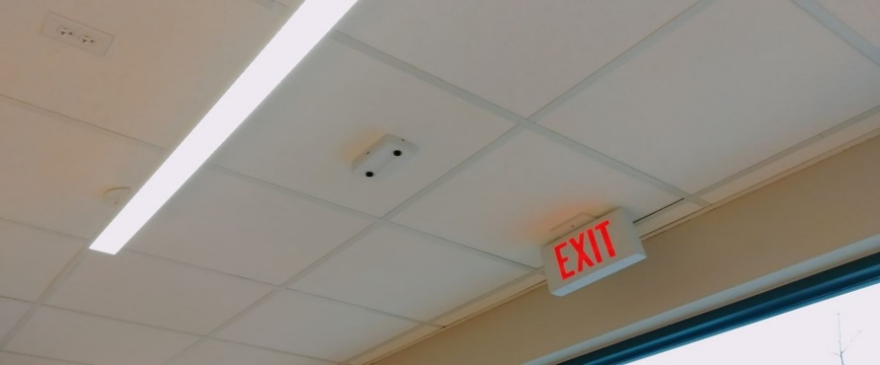
Shopper Trak – Closed Ceiling

Step 5: Access Point Installation
Install the APs using the provided ceiling mount hardware and Meraki's instructions. Connect a patch cable from the surface mount box to the AP. Ensure the access point LED is lit or flashing as a physical check for correct cabling. If the lights are off or not flashing, double-check the cable connections and perform an end-to-end wire map test to ensure accuracy. If needed, J.Crew IT can remotely validate wiring and AP connectivity.
Example
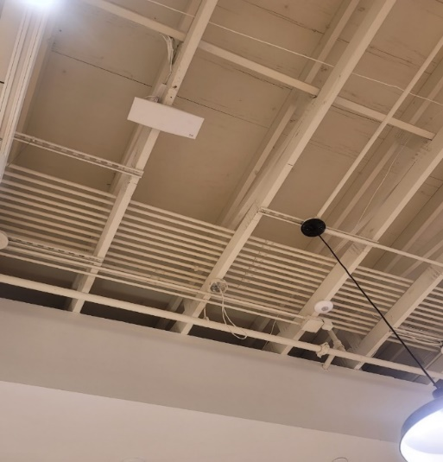

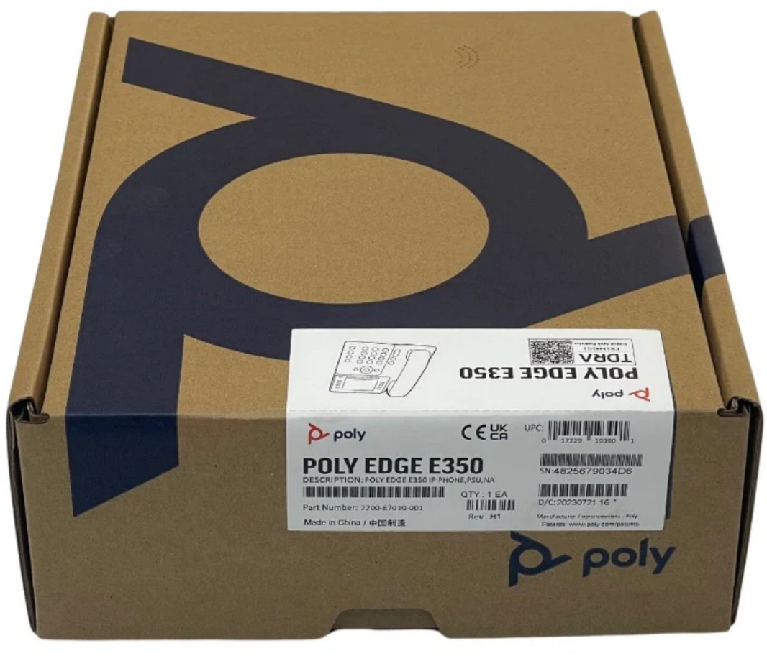

Step 6: Phone Installation
- Locate the boxes labeled "POLY." There will be two boxes in total: one containing the phones and the other containing the mounts.
- Inside one of these boxes, you will find a sheet of paper that clearly designates the intended location for each phone within the installation.
- Note that the phones operate using Power over Ethernet (PoE) and do not require the provided power supply.
  - Example
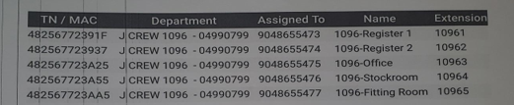

Phone for Cashwrap Drawer
*NEW PHONES WILL BEGIN TO START ARRIVING TO SITE AND LOOK LIKE BELOW:
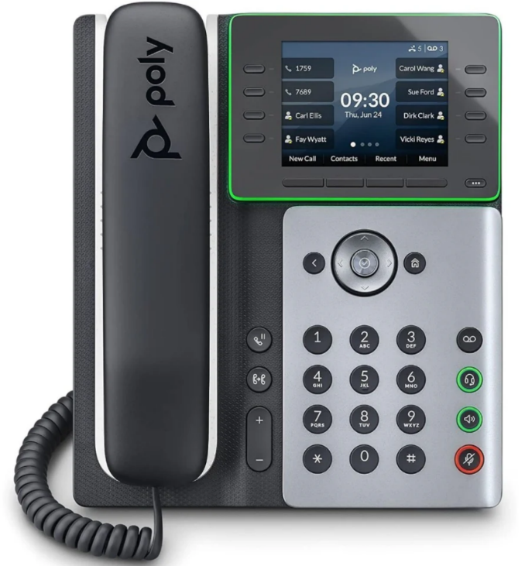

Equipment Validation and Close Out
After finishing all tasks, get in touch with J.Crew IT to check if everything is working online and if anything else is needed. When J.Crew confirms that all systems are online and no further action is required, take the necessary photos and fill out the work order thoroughly. Finally, send the completed work order and associated materials to jcrewsupport@wachter.com and inform the Wachter Project Manager for the final check-out before leaving site, please!

