NCD Anchor Screws
Anchor screws to secure the NCDs inside the fixture will now be provided by Connection and included with the main RT equipment delivery. Each shipment will include ___ screws (___ per drawer) and need to be verified as received at the time of inventory.
***ADD PHOTO OF SCREWS/PACKAGING***

JCI Cabling, Labeling
LV vendor is required to complete the security pre-wire for JCI. This will require a mix of 22/4c electrical cable for BA devices (purple on security drawings) and black Cat6 data cable for video devices (blue on security drawings). When applying for permits, the LV vendor should check if the local municipality will require j-boxes for security end devices.
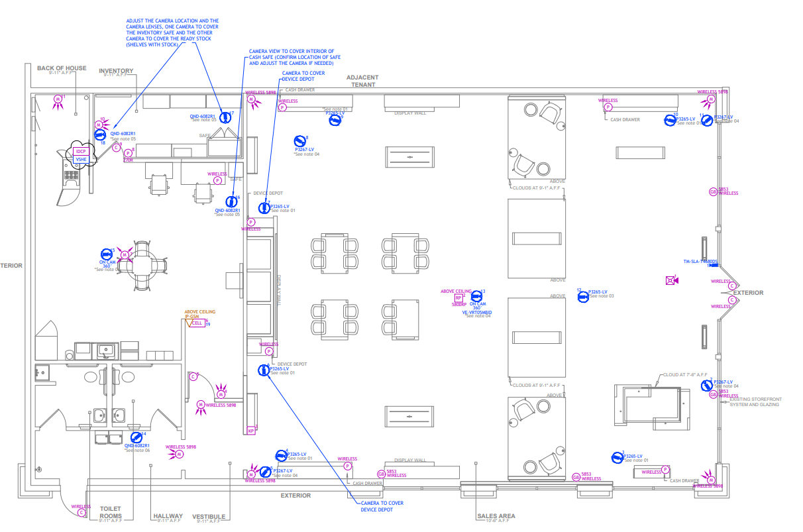
All JCI cables will be ran with a 5’ service loop on the sales floor and a service loop that reaches the floor at the network rack. 22/4 cables for BA devices will be labeled with the corresponding device number from the security drawings. To prevent confusion with other data cables, JCI data cables should be labeled “JCI##” on both ends, with the ## being replaced with the corresponding device number from the security design drawings.
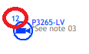
  - The cable for this camera would be labeled “JCI 12” on both ends
**NOTE: in certain instances, some BA devices can/will be wireless but will be specifically indicated as such on the security drawings if so. The panic alarm in the inventory room will never be wireless and will always get a 22/4 cable. Stores located inside malls will require 22/4 cables to every BA device as well (no wireless).
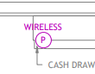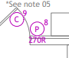

AP Labeling
If the FOH ceiling is to remain white after the remodel and existing APs reused, the LV technician will need to clean the APs as best as possible. This will include removing the existing, yellowing device labels and replacing with new labels that conform to the current TMO naming convention below.
1(XX)A(YY)E(ZZZZ)
The 1, A, and E in the above template will be the same for every AP regardless of location for this project. The underlined parentheses should be replaced with the below:
- XX – Two letter state abbreviation
- YY – AP indicator (01, 02, 03, 22, 23)
- ZZZZ – store SAP
Example: “1OKA01E3SJO” is AP-01 at store 3SJO in Oklahoma

